**Testing Basics**

**a). Introduction to Software Testing?**

Software testing is nothing but an art of investigating software to ensure that its quality under test is in line with the requirement of the client. Software testing is carried out in a systematic manner with the intent of finding defects in a system. It is required for evaluating the system. As the technology is advancing we see that everything is getting digitized. You can access your bank online, you can shop from the comfort of your home, and the options are endless. Have you ever wondered what would happen if these systems turn out to be defective? One small defect can cause a lot of financial loss. It is for this reason that software testing is now emerging as a very powerful field in IT.

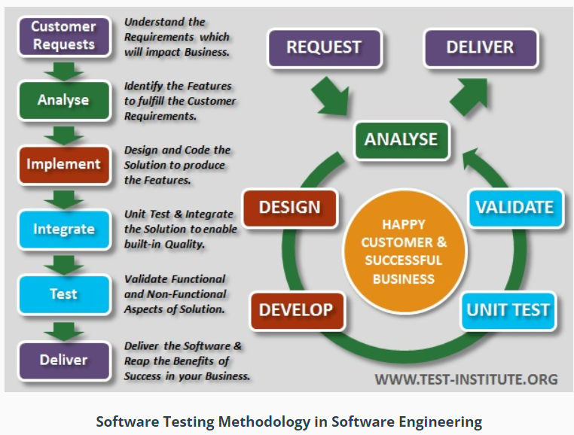

**b) Types of Software Testing:** It is broadly categorized into Functional and Non- Functional Testing.

**Function testing:** It is a type of software testing which is used to verify the functionality of the software application, whether the function is working according to the requirement specification. In functional testing, each function tested by giving the value, determining the output, and verifying the actual output with the expected value. Functional testing performed as black-box testing which is presented to confirm that the functionality of an application or system behaves as we are expecting. It is done to verify the functionality of the application.

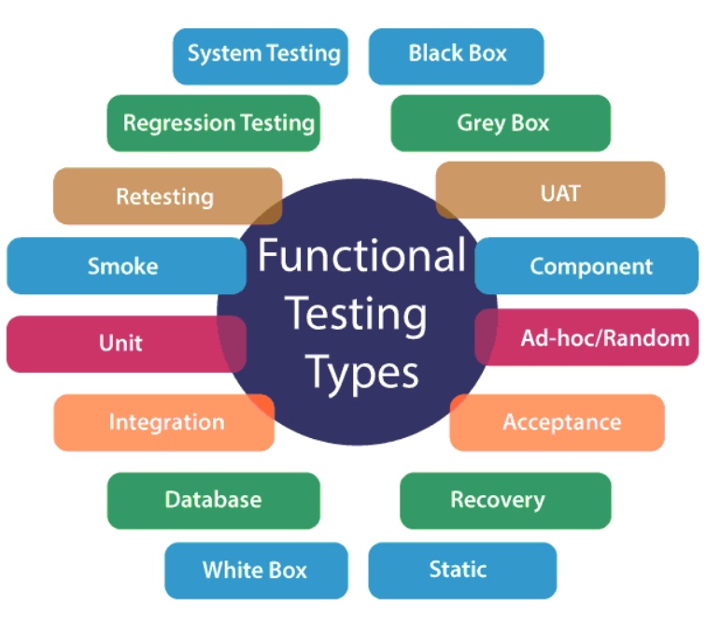

**Non- functional Testing:** Non-functional testing is a type of software testing to test non-functional parameters such as reliability, load test, performance and accountability of the software. The primary purpose of non-functional testing is to test the reading speed of the software system as per non-functional parameters. The parameters of non-functional testing are never tested before the functional testing.Non-functional testing is also very important as functional testing because it plays a crucial role in customer satisfaction.

For example, non-functional testing would be to test how many people can work simultaneously on any software.

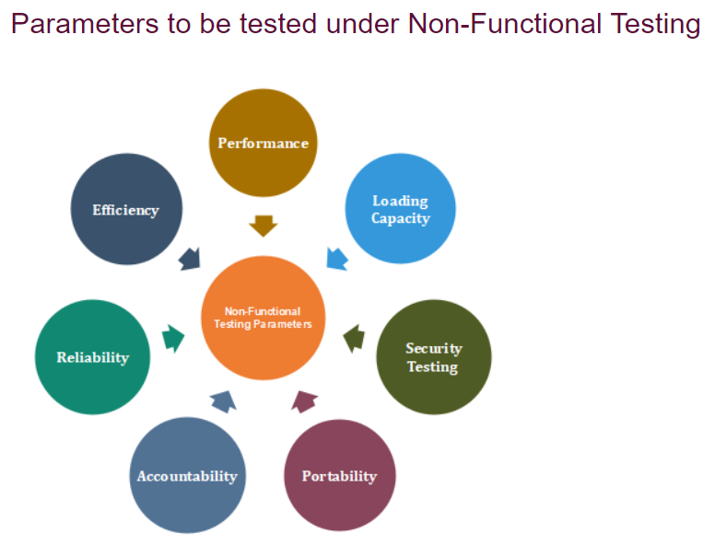

**c) The V- Model:** In software engineering, V-Model also referred to as the Verification and Validation Model. In this, each phase of SDLC must complete before the next phase starts. It follows a sequential design process same as the waterfall model. Testing of the device is planned in parallel with a corresponding stage of development.

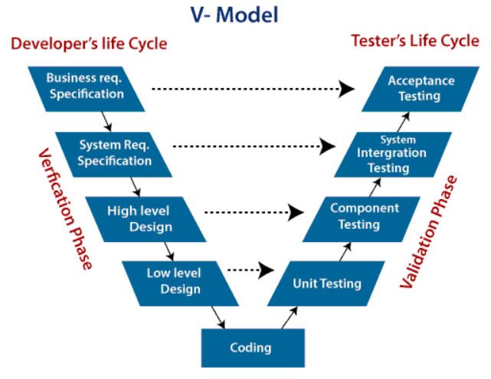

**Verification:** It involves a static analysis method (review) done without executing code. It is the process of evaluation of the product development process to find whether specified requirements meet.

**Validation:** It involves dynamic analysis method (functional, non-functional), testing is done by executing code. Validation is the process to classify the software after the completion of the development process to determine whether the software meets the customer expectations and requirements. So V-Model contains Verification phases on one side of the Validation phases on the other side. Verification and Validation process is joined by coding phase in V-shape. Thus it is known as V-Model.

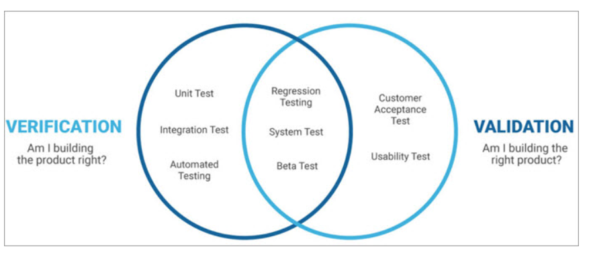

**d) Unit Testing:** Unit testing involves the testing of each unit or an individual component of the software application. It is the first level of functional testing. The aim behind unit testing is to validate unit components with its performance.A unit is a single testable part of a software system and tested during the development phase of the application software. The purpose of unit testing is to test the correctness of isolated code. A unit component is an individual function or code of the application. White box testing approach used for unit testing and usually done by the developers. Whenever the application is ready and given to the Test engineer, he/she will start checking every component of the module or module of the application independently or one by one, and this process is known as **Unit testing** or **components testing**.

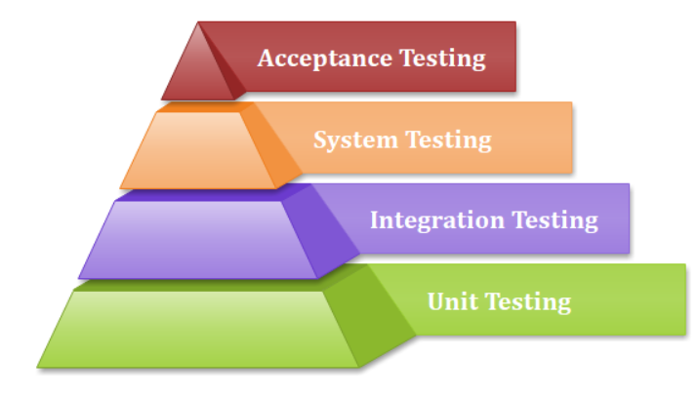

**e) Integration Testing:** It is the second level of the software testing process comes after unit testing. In this testing, units or individual components of the software are tested in a group. The focus of the integration testing level is to expose defects at the time of interaction between integrated components or units. [Unit testing](https://www.javatpoint.com/unit-testing) uses modules for testing purpose, and these modules are combined and tested in integration testing. The Software is developed with a number of software modules that are coded by different coders or programmers. The goal of integration testing is to check the correctness of communication among all the modules.

Once all the components or modules are working independently, then we need to check the data flow between the dependent modules is known as **integration testing**.

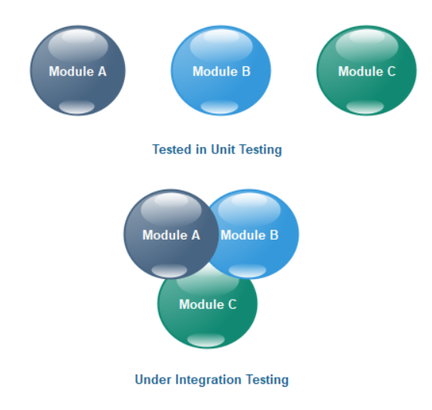

**f) System Testing:** System Testing includes testing of a fully integrated software system. Generally, a computer system is made with the integration of software (any software is only a single element of a computer system). The software is developed in units and then interfaced with other software and hardware to create a complete computer system. In other words, a computer system consists of a group of software to perform the various tasks, but only software cannot perform the task; for that software must be interfaced with compatible hardware. System testing is a series of different type of tests with the purpose to exercise and examine the full working of an integrated software computer system against requirements.

To check the end-to-end flow of an application or the software as a user is known as **System testing**. In this, we navigate (go through) all the necessary modules of an application and check if the end features or the end business works fine, and test the product as a whole system.

**g) Acceptance Testing:** Acceptance testing is formal testing based on user requirements and function processing. It determines whether the software is conforming specified requirements and user requirements or not. It is conducted as a kind of Black Box testing where the number of required users involved testing the acceptance level of the system. It is the fourth and last level of software testing.

**h) Difference between White & Black & Gray Box Testing**

[**Black Box Testing**](https://www.geeksforgeeks.org/software-engineering-black-box-testing/)**:** Black box testing is a type of software testing in which the functionality of the software is not known. The testing is done without the internal knowledge of the products. It is also called Functional testing. Black-box testing focuses on software’s external attributes and behavior. This type of testing looks at an application’s software expected behavior from the user’s point of view.

[**White Box Testing**](https://www.geeksforgeeks.org/software-engineering-white-box-testing/)**:** White-box testing or glass-box testing is a software testing technique that tests the software by using the knowledge of internal data structures, physical logic flow, and architecture at the level of source code. This testing works by looking at testing from the developer’s point of view. This testing is also known as glass box testing, clear box testing, structural testing, or non-functional testing.

[**Gray Box Testing**](https://www.geeksforgeeks.org/gray-box-testing-software-testing/)**:** Gray Box Testing is a combination of the Black Box Testing technique and the White Box Testing technique in software testing. The gray-box testing involves inputs and outputs of a program for the testing purpose but test design is tested by using the information about the code. Gray-box testing is well suited for web application testing because it factors in a high-level design environment and the inter-operability conditions.

**i) Difference between Alpha and Beta Testing**

|  |  |
| --- | --- |
| **Alpha Testing**  i) Alpha testing involves both the white box and black box testing.  ii) Alpha testing is performed by testers who are usually internal employees of the organization.  iii) Alpha testing is performed at the developer’s site.  iv) Alpha testing ensures the quality of the product before forwarding to beta testing.  v) Developers can immediately address the critical issues or fixes in alpha testing. | **Beta Testing**  i) Beta testing commonly uses black-box testing.    ii) Beta testing is performed by clients who are not part of the organization.  iii) Alpha testing is performed at the developer’s site.  iv) Beta testing also concentrates on the quality of the product but collects users input on the product and ensures that the product is ready for real time users.  v) Most of the issues or feedback collected from the beta testing will be implemented in future versions of the product. |

**j) Regression Testing:** It is a black box testing techniques. It is used to authenticate a code change in the software does not impact the existing functionality of the product. Regression testing is making sure that the product works fine with new functionality, [bug](https://www.javatpoint.com/bug-in-software-testing) fixes, or any change in the existing feature.

Regression testing can be performed on a new build when there is a significant change in the original functionality. It ensures that the code still works even when the changes are occurring. Regression means Re-test those parts of the application, which are unchanged.

**Example of Regression testing:** Consider a product Y, in which one of the functionality is to trigger confirmation, acceptance, and dispatched emails. It also needs to be tested to ensure that the change in the code not affected them. Regressing testing does not depend on any programming language like [Java](https://www.javatpoint.com/java-tutorial), [C++](https://www.javatpoint.com/cpp-tutorial), [C#](https://www.javatpoint.com/c-sharp-tutorial), etc. This method is used to test the product for modifications or any updates done. It ensures that any change in a product does not affect the existing module of the product. Verify that the bugs fixed and the newly added features not created any problem in the previous working version of the Software.

**k) Introduction to Review :** Reviews are the form of static testing. In software reviews people analyze the work product of projects such as requirements document, design document, test strategy, test plan in order to find out any defects in the documents. Software Reviews, if done properly are the biggest and most cost effective contributor to product quality.

**l) Data flow Graph & Control flow Graph & Cyclomatic Complexity Metric:**Cyclomatic complexity is a source code complexity measurement that is being correlated to a number of coding errors. It is calculated by developing a Control Flow Graph of the code that measures the number of linearly-independent paths through a program module.

Cyclomatic complexity = E - N + 2*P

where,

E = number of edges in the flow graph.

N = number of nodes in the flow graph.

P = number of nodes that have exit points

**Flow graph notation for a program:** Flow Graph notation for a program defines several nodes connected through the edges. Below are Flow diagrams for statements like if-else, While, until and normal sequence of flow.

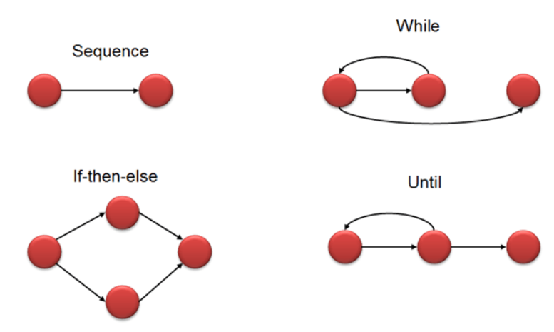

**Flow graph for this program will be**

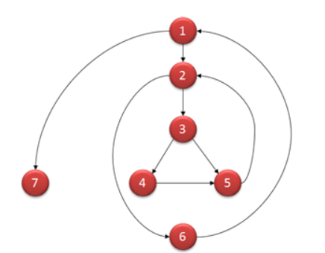

**Example:**

i = 0;

n=4; //N-Number of nodes present in the graph

while (i<n-1) do

j = i + 1;

while (j<n) do

if A[i]<A[j] then

swap(A[i], A[j]);

end do;

j=j+1;

end do;

**n) Writing Test Cases:**

**Test Plan:** Test plan is a Document, developed by the Test Lead, which contains "What to Test", "How to Test", "When to Test", "Who to Test".

**Test Strategy:** Test Strategy is a Document, developed by the Project manager, which contains what type of technique to follow and which module to test.

**Test Scenario:** A name given to Test Cases is called Test Scenario. This Test Scenario was deal by the Test Engineers.

**Test Cases:** It is also document and it specifies a Testable condition to validate functionality. These Test Cases are deal by the Test Engineers

**Practical No. 2**

**Aim: Implement Web drivers on Chrome & Firefox.**

**2.1) Implement web driver on chrome for amazon.**

**Code:**

**package** test;

**import** org.openqa.selenium.WebDriver;

**import** org.openqa.selenium.chrome.ChromeDriver;

**public** **class** testclass {

**public** **static** **void** main(String[] args) {

// **TODO** Auto-generated method stub

System.*setProperty*("webdriver.chrome.driver", "D:\\Selenium-SoftwareTesting\\chromedriver.exe" );

WebDriver driver=**new** ChromeDriver();

driver.get("http://www.amazon.com");

System.***out***.println(driver.getTitle());

}

}

**OUTPUT:**

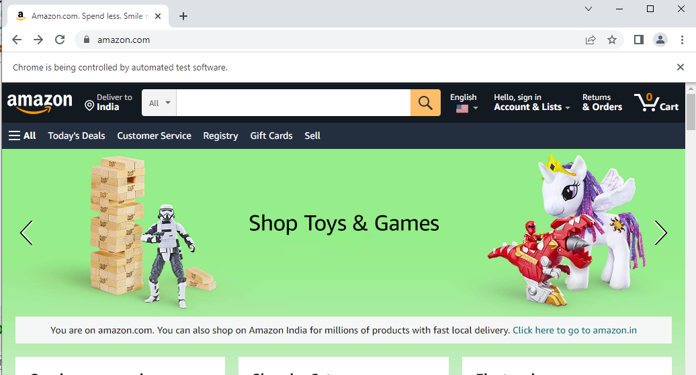

**2.2) Implement web driver on chrome for Olacabs.**

**Code:**

**package** test;

**import** org.openqa.selenium.WebDriver;

**import** org.openqa.selenium.chrome.ChromeDriver;

**public** **class** testclass {

**public** **static** **void** main(String[] args) {

// **TODO** Auto-generated method stub

System.*setProperty*("webdriver.chrome.driver", "D:\\Selenium-SoftwareTesting\\chromedriver.exe" );

WebDriver driver=**new** ChromeDriver();

driver.get("http://www.ola.com");

System.***out***.println(driver.getTitle());

}

}

**OUTPUT:**

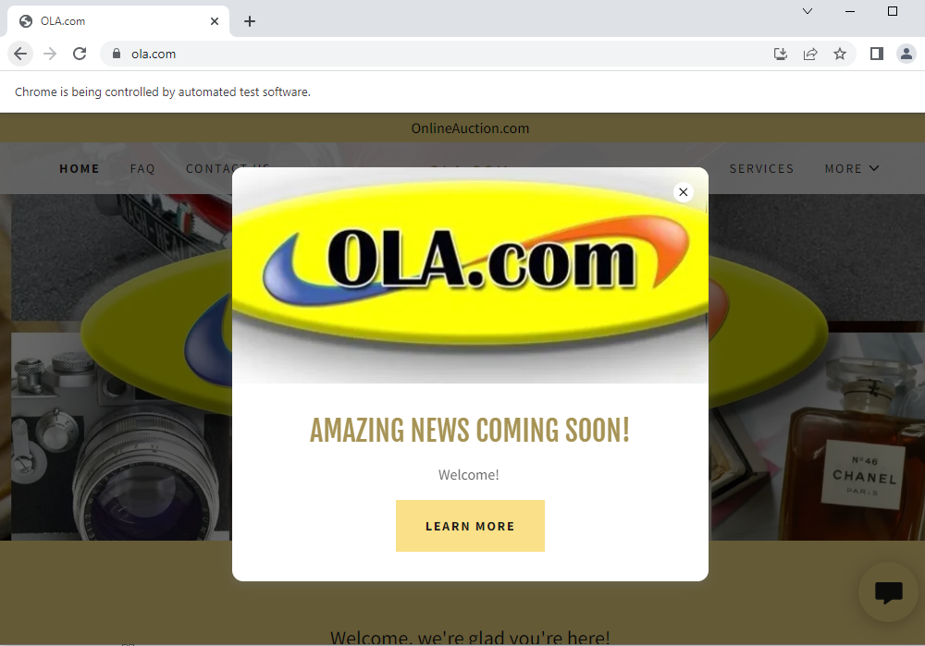

**2.3) Implement Web Drivers on Firefox for Olacabs.**

**Code:**

**package** Practa1;

**import** org.openqa.selenium.WebDriver;

**import** org.openqa.selenium.firefox.FirefoxDriver;

**public** **class** PractA1 {

**public** **static** **void** main(String[] args) {

// **TODO** Auto-generated method stub

System.*setProperty*("webdriver.gecko.driver","D:\\Selenium-SoftwareTesting\\geckodriver.exe");

WebDriver driver=**new** FirefoxDriver();

driver.get("https://www.olacabs.com");

System.***out***.println(driver.getTitle());

}

}

**OUTPUT:**

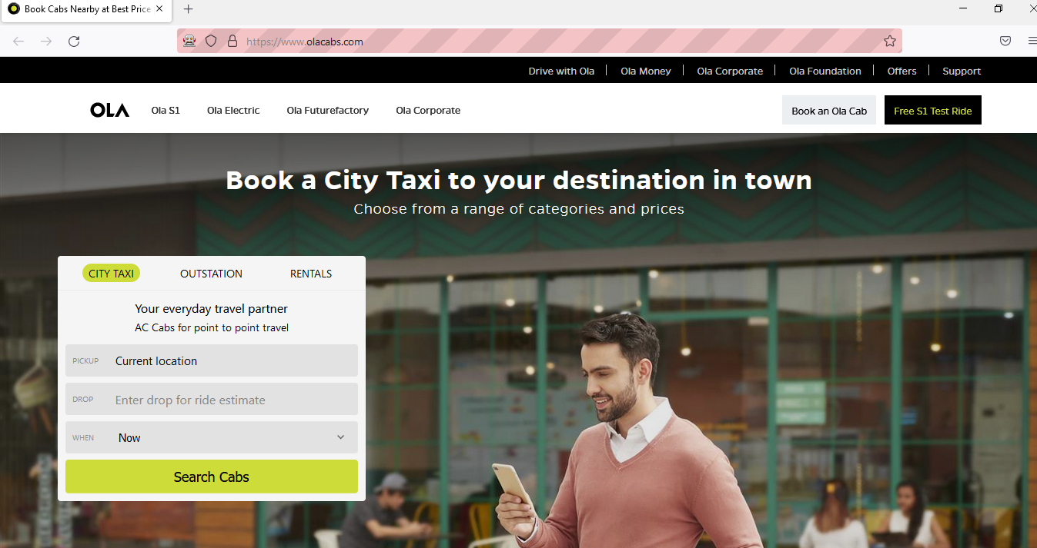

**Practical No. 3**

**Aim: Implement Web drivers on Single platform using Chrome and Firefox browser.**

**3.1) Implement web drivers on single platform using Chrome and Firefox browser with Google search engine**

**Code:**

**package** multibrows;

**import** java.util.Scanner;

**import** org.openqa.selenium.WebDriver;

**import** org.openqa.selenium.chrome.ChromeDriver;

**import** org.openqa.selenium.firefox.FirefoxDriver;

**public** **class** crfi {

**static** WebDriver *wd*;

**public** **static** **void** main(String[] args) {

// **TODO** Auto-generated method stub

WebDriver wd=**null**;

Scanner sc = **new** Scanner(System.***in***);

System.***out***.println("Choice");

System.***out***.println("1.ChromeBrowser \n 2. Firefox Browser");

**int** ch = sc.nextInt();

sc.close();

**switch** (ch)

{

**case** 1:

System.*setProperty*("webdriver.chrome.driver","E:\\Selenium-SoftwareTesting\\chromedriver.exe");

wd = **new** ChromeDriver();

**if**(wd!=**null**)

{

wd.get("https://www.google.com/");

// **TODO** Auto-generated method stub

}

**break**;

**case** 2:System.*setProperty*("webdriver.gecko.driver","E:\\Selenium-SoftwareTesting\\geckodriver.exe");

wd = **new** FirefoxDriver();

**if**(wd!=**null**)

{

wd.get("https://www.google.com/");

// **TODO** Auto-generated method stub

}

**default**:

System.***out***.println("Invalid Choice");

**break**;

}

}

}

**Output:**

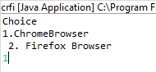

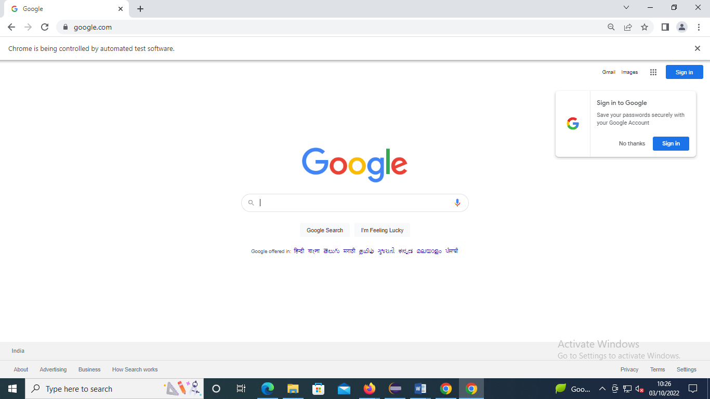

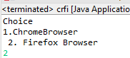

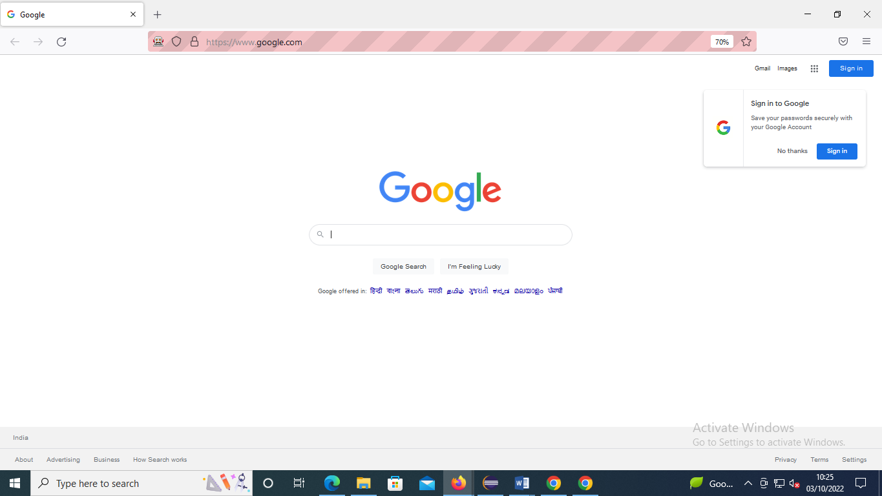

**3.2) Implement web drivers on single platform using chrome and Firefox browser with multiple websites.**

**Code:**

**package** demo;

**import** java.util.*;

**import** org.openqa.selenium.WebDriver;

**import** org.openqa.selenium.chrome.ChromeDriver;

**import** org.openqa.selenium.firefox.FirefoxDriver;

**public** **class** test {

**static** WebDriver *wd*;

**public** **static** **void** main(String[] args) {

// **TODO** Auto-generated method stub

Scanner sc = **new** Scanner(System.***in***);

System.***out***.println("Choice");

System.***out***.println("1.ChromeBrowser\n2.Firefox Browser");

**int** ch = sc.nextInt();

sc.close();

**switch** (ch)

{

**case** 1:

System.*setProperty*("webdriver.chrome.driver","D:\\Selenium-SoftwareTesting\\chromedriver.exe");

*wd* = **new** ChromeDriver();

**if**(*wd*!=**null**){

*wd*.get("http:\\amazon.com");

}

**break**;

**case** 2:

System.*setProperty*("webdriver.gecko.driver","D:\\Selenium-SoftwareTesting\\geckodriver.exe");

*wd* = **new** FirefoxDriver();

**if**(*wd*!=**null**){

*wd*.get("http:\\flipkart.com");

}

**default**:

System.***out***.println("Invalid Choice");

**break**;

}

}

}

**Output:**

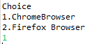

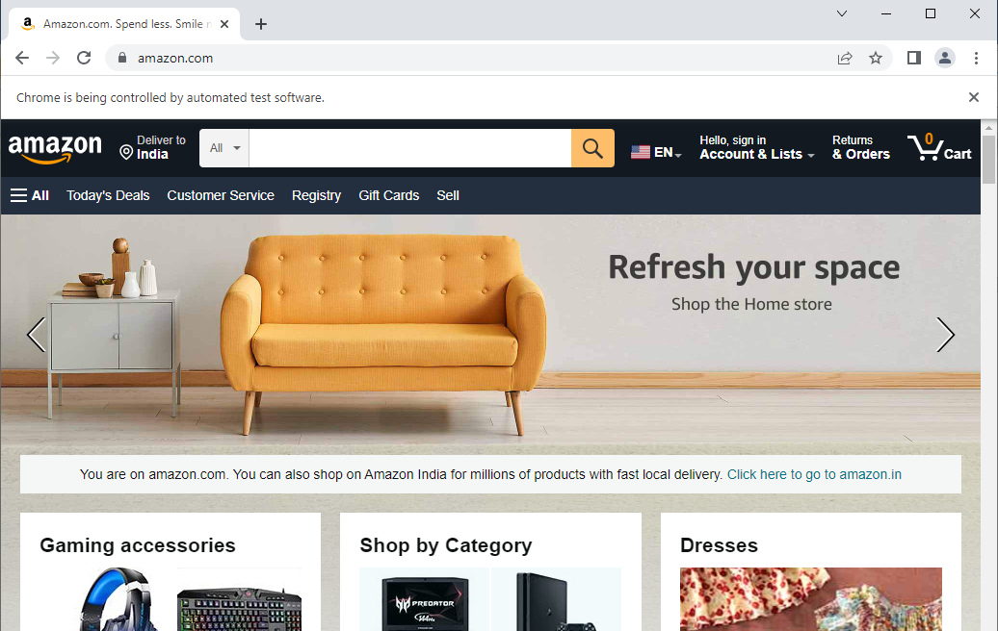

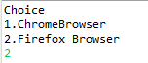

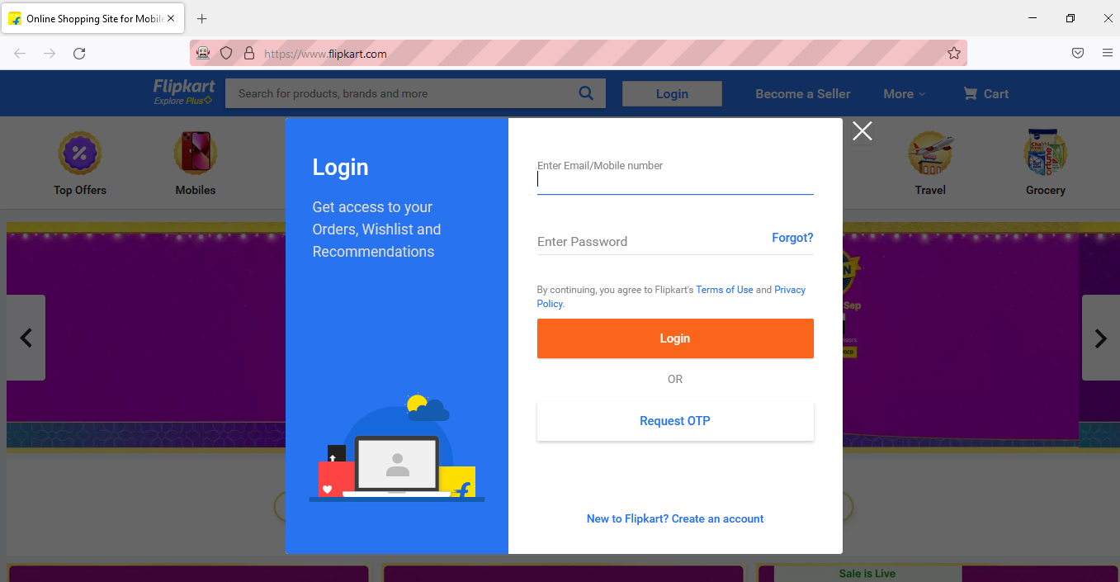

**Practical No. 4**

**Aim: To demonstrate the locators (ID, class name, linked text, Partial linked, tag name)**

**4.1) Using ID, class name, tag name.**

**Code:**

**package** com.project

**import** org.openqa.selenium.By;

**import** org.openqa.selenium.WebDriver;

**import** org.openqa.selenium.WebElement;

**import** org.openqa.selenium.chrome.ChromeDriver;

**public** **class** locateId_name {

**public** **static** **void** main(String[] args) {

// **TODO** Auto-generated method stub

System.*setProperty*("webdriver.chrome.driver","D:\\Selenium-SoftwareTesting\\chromedriver.exe");

WebDriver driver = **new** ChromeDriver();

driver.get("http://automationpractice.com/index.php");

driver.manage().window().maximize();// maximize web page

//id &name locator

WebElement searchbox = driver.findElement(By.*id*("search_query_top"));

searchbox.sendKeys("T-shirts");

driver.findElement(By.*name*("submit_search")).click();

}

}

**Output:**



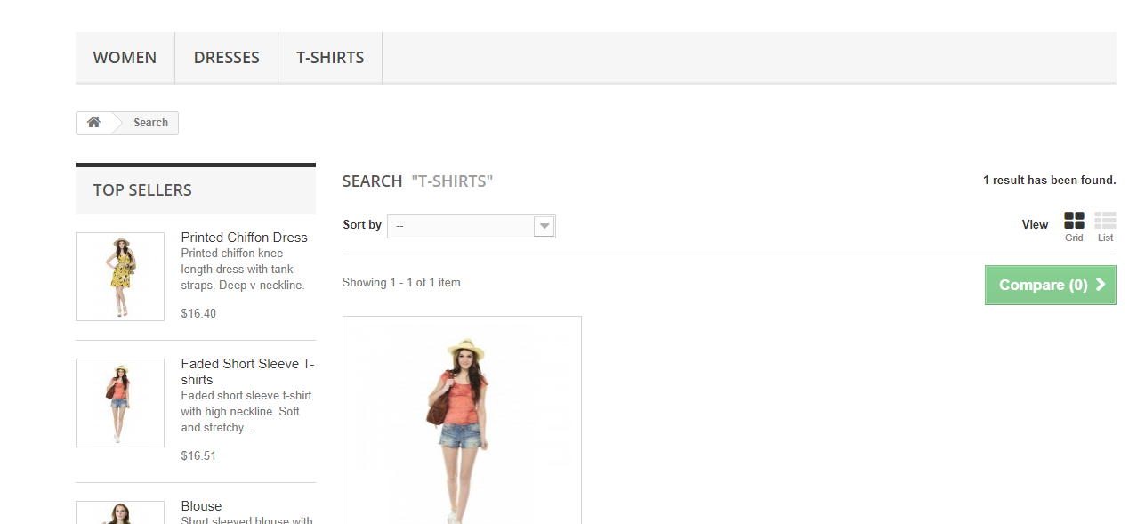

**4.2) Using Linked text and partial linked text.**

**Code:**

**package** siddhi_locators;

**import** org.openqa.selenium.By;

**import** org.openqa.selenium.WebDriver;

**import** org.openqa.selenium.WebElement;

**import** org.openqa.selenium.chrome.ChromeDriver;

**public** **class** locateId_name {

**public** **static** **void** main(String[] args) {

// **TODO** Auto-generated method stub

System.*setProperty*("webdriver.chrome.driver","D:\\Selenium-SoftwareTesting\\chromedriver.exe");

WebDriver driver = **new** ChromeDriver();

driver.get("http://automationpractice.com/index.php");

driver.manage().window().maximize();// maximize web page

//id &name locator

WebElement searchbox = driver.findElement(By.*id*("search_query_top"));

searchbox.sendKeys("T-shirts");

driver.findElement(By.*name*("submit_search")).click();

//linkText & partial linkText

driver.findElement(By.*linkText*("Printed Chiffon Dress")).click();

driver.findElement(By.*partialLinkText*("Chiffon Dress")).click();

}

}

**Output:**



**4.3) Using class name.**

**Code:**

package locatdemo;

import org.openqa.selenium.By;

import org.openqa.selenium.WebDriver;

import org.openqa.selenium.WebElement;

import org.openqa.selenium.chrome.ChromeDriver;

public class orange {

public static void main(String[] args) {

// TODO Auto-generated method stub

System.setProperty("webdriver.chrome.driver","D:\\Selenium-SoftwareTesting\\chromedriver.exe");

WebDriver driver = new ChromeDriver();

driver.get("https://www.orangehrm.com/");

driver.manage().window().maximize();// maximize web page

//id &name locator

WebElement searchbox = driver.findElement(By.id("form-control tryit-email"));

searchbox.sendKeys("Enter your email address here");

driver.findElement(By.name("buttonClick()")).click();

}

}

**Output:**





**4.4) To demonstrate CSS Selector.**

**Code:**

**package** demo;

**import** org.openqa.selenium.By;

**import** org.openqa.selenium.WebDriver;

**import** org.openqa.selenium.firefox.FirefoxDriver;

**public** **class** demo1 {

**public** **static** **void** main(String[] args) {

// **TODO** Auto-generated method stub

System.*setProperty*("webdriver.gecko.driver","D:\\Selenium-SoftwareTesting\\geckodriver.exe");

WebDriver driver = **new** FirefoxDriver();

driver.get("https://www.amazon.in/");

//driver.manage(). ).window().maximize();

//JavascriptExecutor js = (JavascriptExecutor) driver;

driver.findElement(By.*cssSelector*("#twotabsearchtextbox")).sendKeys("OnePlus6T");

driver.findElement(By.*cssSelector*( "#nav-search-submit-button")).click();

//js.executeScript(1 ("window. .scrollBy(0,300)");

}

}

**Output:**

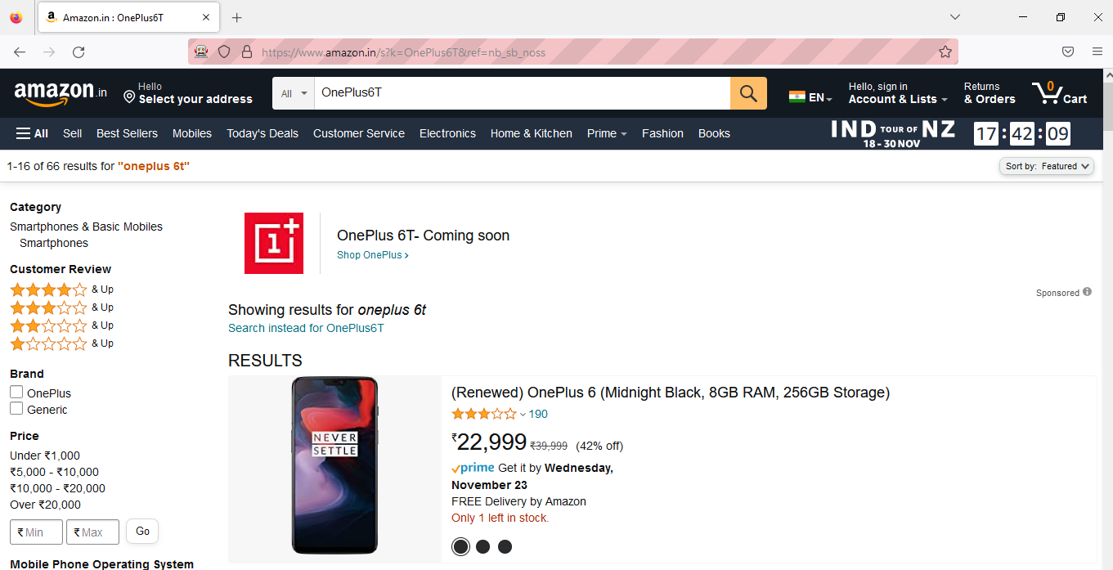

**4.5) To demonstrate XPath.**

**Code:**

**package** xpath;

**import** java.util.concurrent.TimeUnit;

**import** org.openqa.selenium.By;

**import** org.openqa.selenium.WebDriver;

**import** org.openqa.selenium.WebElement;

**import** org.openqa.selenium.chrome.ChromeDriver;

**import** org.openqa.selenium.firefox.FirefoxDriver;

**public** **class** xpath {

**public** **static** **void** main(String[] args) {

// **TODO** Auto-generated method stub

System.*setProperty*("webdriver.gecko.driver","D:\\Selenium-SoftwareTesting\\geckodriver.exe");

WebDriver driver = **new** FirefoxDriver();

driver.manage().window().maximize();

driver.manage().deleteAllCookies();

driver.manage().timeouts().~~pageLoadTimeout~~(40,TimeUnit.***SECONDS***);

driver.manage().timeouts().~~implicitlyWait~~(30,TimeUnit.***SECONDS***);

driver .get("https://amazon.in/");

driver.findElement(By.*xpath*("//input[@id='twotabsearchtextbox']")).sendKeys("Guitar");

WebElement searchIcon=driver.findElement(By.*xpath*("//input[@id='nav-search-submit-button']"));

searchIcon.click();

}}

**Output:**

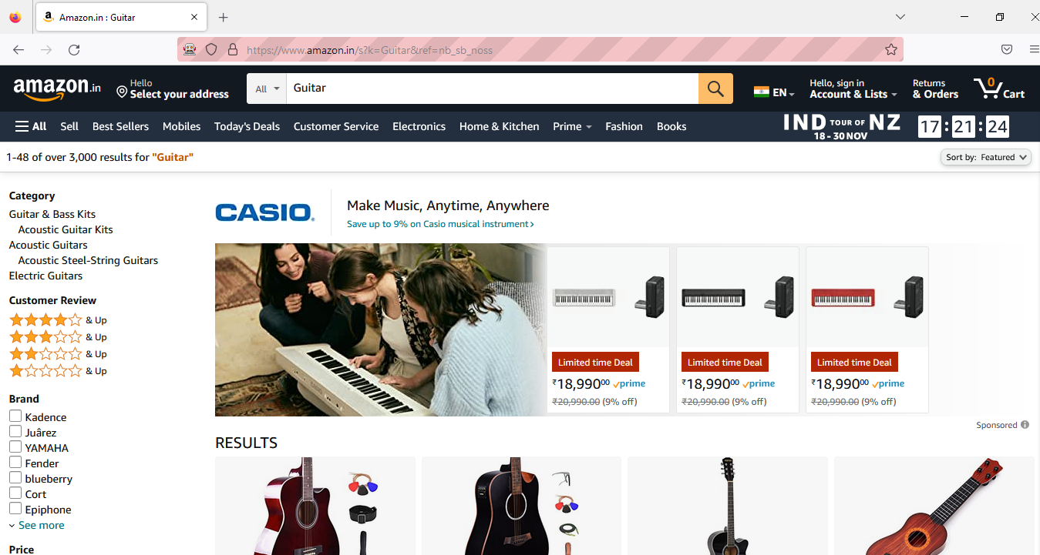

**Practical 5**

**Aim: Demonstrate Synchronization in Selenium (Implicit, Explicit and Fluent Waits).**

**5.1) To demonstrate Implicit Waits.**

**Code:**

**package** implicit;

**import** java.util.concurrent.TimeUnit;

**import** org.openqa.selenium.By;

**import** org.openqa.selenium.WebDriver;

**import** org.openqa.selenium.chrome.ChromeDriver;

**public** **class** implicit {

**public** **static** **void** main(String[] args) **throws** InterruptedException {

// **TODO** Auto-generated method stub

System.*setProperty*("webdriver.chrome.driver","D:\\Selenium-SoftwareTesting\\chromedriver.exe");

WebDriver driver = **new** ChromeDriver();

driver.manage().window().maximize();

driver.manage().deleteAllCookies() ;

driver.manage().timeouts().~~pageLoadTimeout~~ (40,TimeUnit.***SECONDS***) ;

driver.manage().timeouts().~~implicitlyWait~~(20, TimeUnit.***SECONDS***);

driver.get("https://login.yahoo.com/");

driver.findElement(By.*xpath*("//input[@id='login-username']")).sendKeys("abc@yahoo.com");

Thread.*sleep*(3000);

driver.findElement(By.*xpath*("//input[@id='login-signin']")).click();

}

}

**Output:**

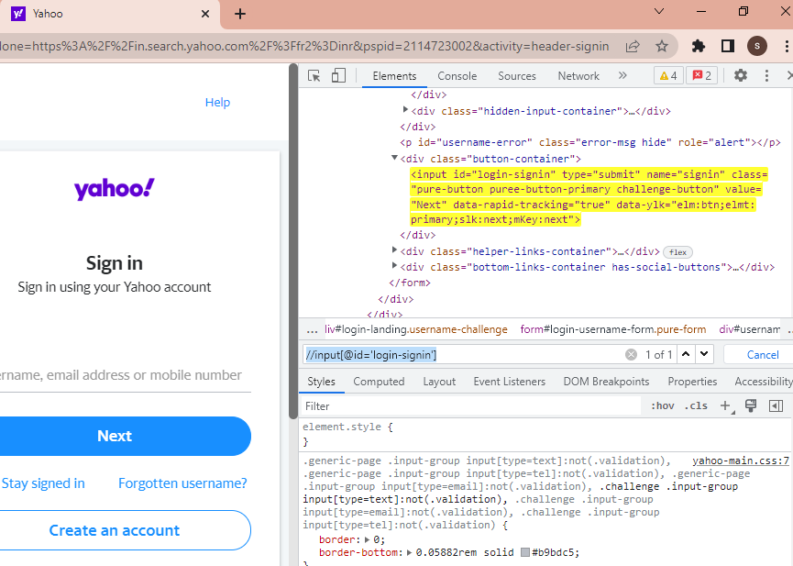

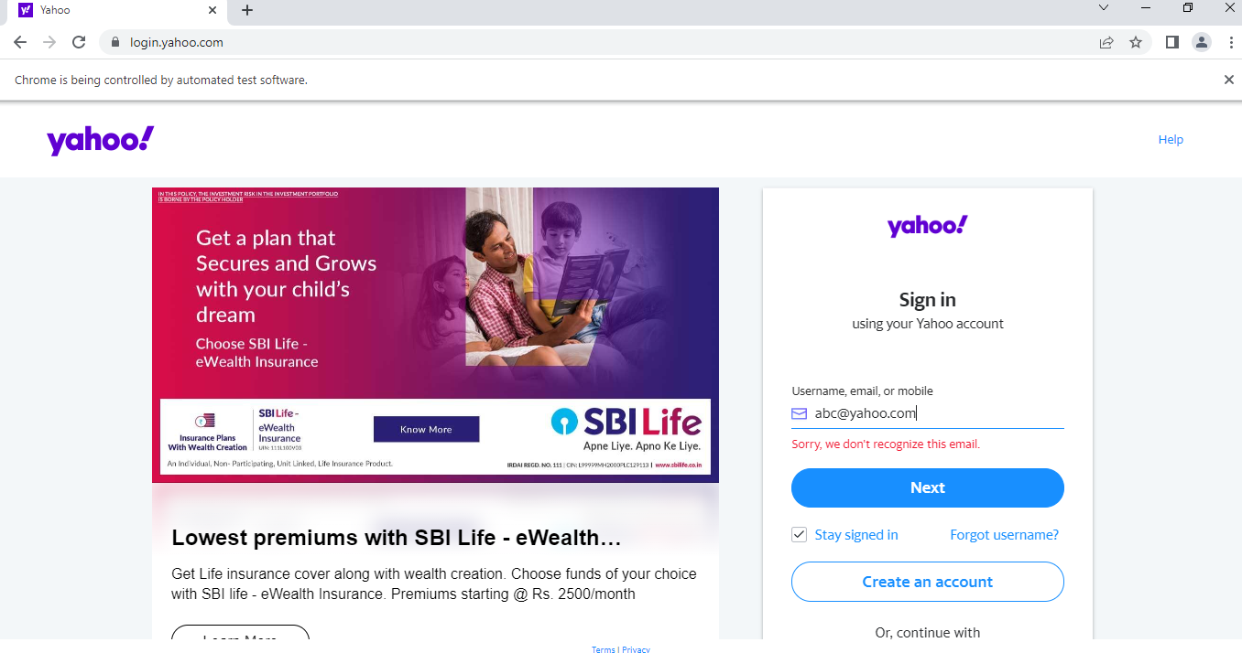

**5.2) To demonstrate Explicit Waits.**

**Code:**

**package** practical5b;

**import** java.time.Duration;

**import** java.util.concurrent.TimeUnit;

**import** org.openqa.selenium.By;

**import** org.openqa.selenium.WebDriver;

**import** org.openqa.selenium.WebElement;

**import** org.openqa.selenium.chrome.ChromeDriver;

**import** org.openqa.selenium.support.ui.ExpectedConditions;

**import** org.openqa.selenium.support.ui.WebDriverWait;

**public** **class** practical5b {

**public** **static** **void** main(String[] args)**throws** InterruptedException {

// **TODO** Auto-generated method stub

System. *setProperty*("webdriver.chrome.driver","D:\\Eclipse Practical\\chromedriver.exe");

WebDriver driver = **new** ChromeDriver();

driver.manage().window().maximize();

driver.manage().deleteAllCookies() ;

driver.manage().timeouts().~~pageLoadTimeout~~ (40, TimeUnit.***SECONDS***) ;

driver.manage().timeouts().~~implicitlyWait~~(20, TimeUnit.***SECONDS***);

driver. get ("https://www.facebook.com/");

//driver. findElement (By.xpath("//input [@id=’login-username’]")).sendKeys("abc@yahoo.com");

//Thread. sleep(3000) ;

//driver. findElement (By.xpath ("//input [@id= ‘login-signin']”)).click();

WebElement firstname= driver. findElement (By.*name*("firstname"));

WebElement lastname= driver. findElement (By.*name*("lastname"));

*sendKeys*(driver, firstname, 10, "Yahoo");

*sendKeys*(driver, lastname, 20, "YouTube");

WebElement forgotAccount= driver. findElement (By.*linkText* ("Forgotten account?"));

*clickOn*(driver, forgotAccount, 10);

}

**private** **static** **void** sendKeys(WebDriver driver, WebElement element, **int** timeout, String value) {

// **TODO** Auto-generated method stub

**new** WebDriverWait(driver, timeout).until(ExpectedConditions.*visibilityOf*(element));

element.sendKeys(value);

}

**private** **static** **void** clickOn(WebDriver driver, WebElement element, **int** timeout) {

// **TODO** Auto-generated method stub

**new** WebDriverWait(driver, timeout).until(ExpectedConditions.*elementToBeClickable*(element));

element.click();

}

}

**Output:**

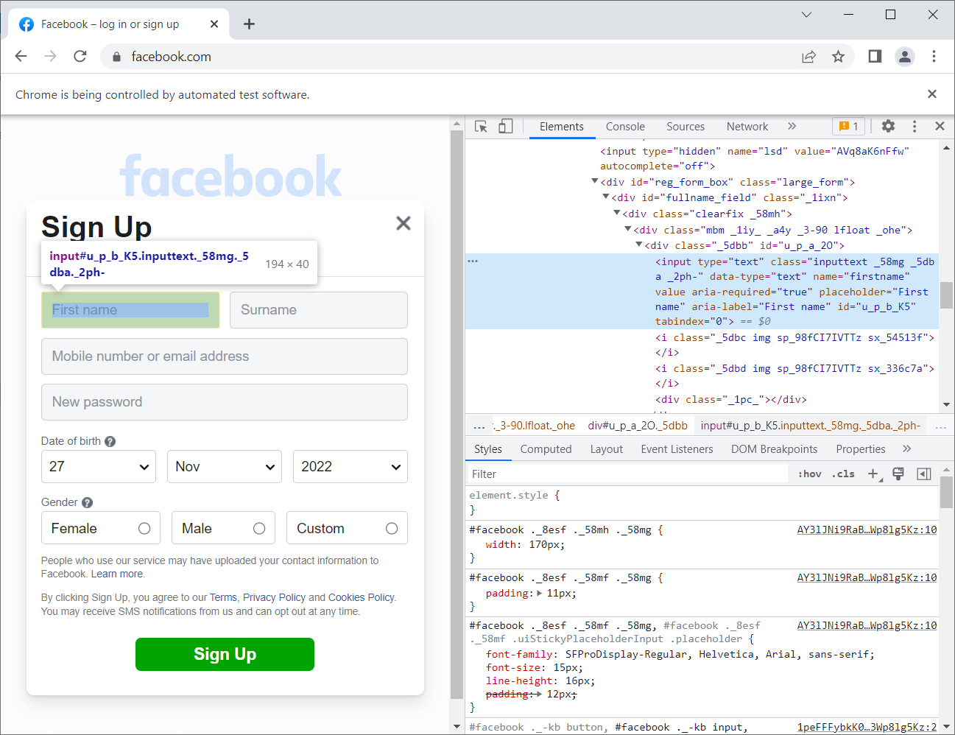

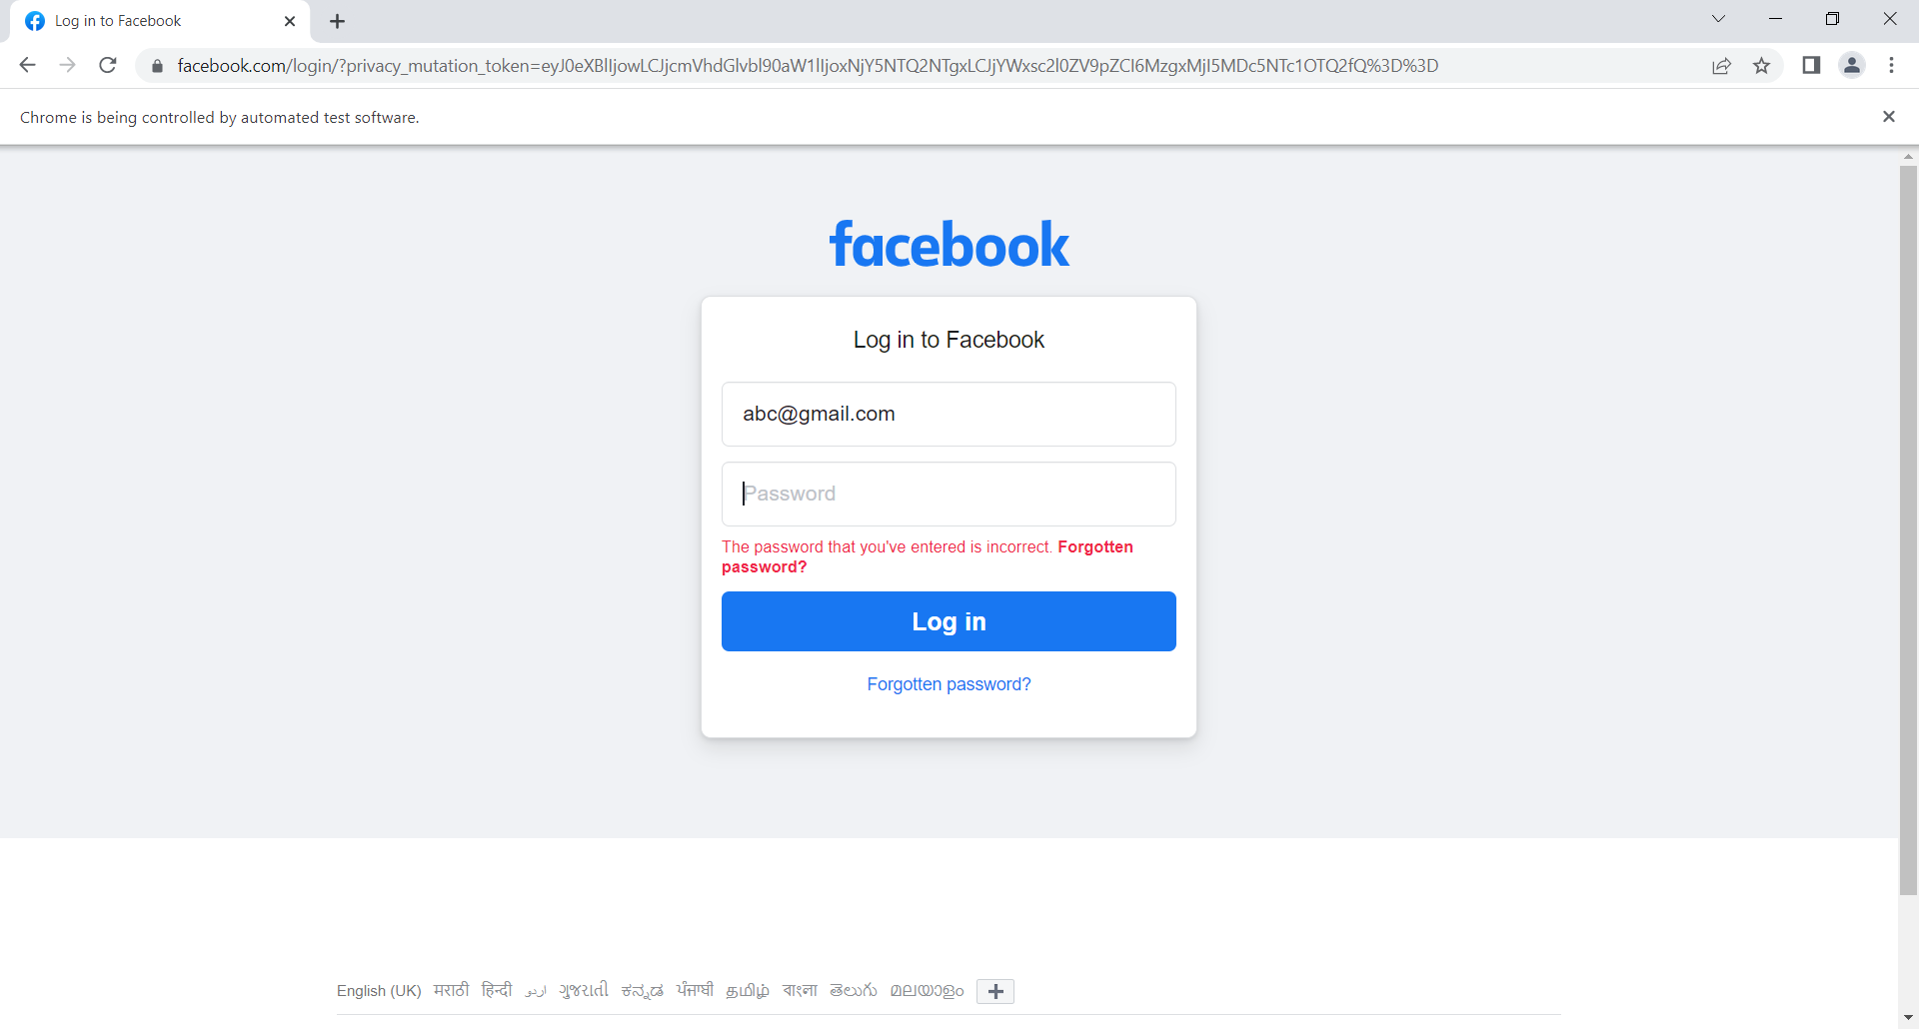

**Practical 6**

**Aim: Demonstrate different types of alert in Selenium.**

**Code:**

**Practical6a.java:**

**package** Practical6a;

**import** java.awt.AWTException;

**import** java.awt.Robot;

**import** java.awt.event.InputEvent;

**import** org.openqa.selenium.Alert;

**import** org.openqa.selenium.By;

**import** org.openqa.selenium.WebDriver;

**import** org.openqa.selenium.chrome.ChromeDriver;

**public** **class** Practical6a {

**public** **static** **void** main(String[] args)**throws** InterruptedException, AWTException {

// **TODO** Auto-generated method stub

System.*setProperty*("webdriver.chrome.driver", "D:\\\\Eclipse Practical\\\\chromedriver.exe");

WebDriver driver = **new** ChromeDriver();

driver.get("D:\\Eclipse Practical\\Practical6a\\src\\Alert.html");

driver.manage().window().maximize();

Thread.*sleep*(3000);

driver.findElement(By.*id*("alert")).click();

Thread.*sleep*(3000);

Alert alert = driver.switchTo().alert();

String alertMessage = driver.switchTo().alert().getText();

System.***out***.println(alertMessage);

Thread.*sleep*(3000);

alert.accept();

Thread.*sleep*(3000);

driver.findElement(By.*id*("PopUp")).click();

Robot robot = **new** Robot();

robot.mouseMove(400, 5);

robot.mousePress(InputEvent.***BUTTON1_DOWN_MASK***);

Thread.*sleep*(2000);

robot.mouseRelease(InputEvent.***BUTTON1_DOWN_MASK***);

Thread.*sleep*(2000);

driver.quit();

}

}

**Alert.html:**

<!DOCTYPE html>

<html>

<body>

<h2>Alerts in Selenium</h2>

<p>Press the keys for multiple alerts.</p>

<!--<input id="myInput" value="Some text.."> -->

<button id=*"myBtn"* onclick="javascript:alert('This is a Selenium Alert Box!')">Display Alert</button>

</br>

</br>

<button id=*"myBtn"* onclick="javascript:alert('This is a Selenium PopUp!')">PopUp</button>

<script>

**var** input = document.getElementById("myInput");

input.addEventListener("keypress", **function**(event) {

**if** (event.key === "Enter") {

event.preventDefault();

document.getElementById("myBtn").click();

}

});

</script>

</body>

</html>

**Output:**

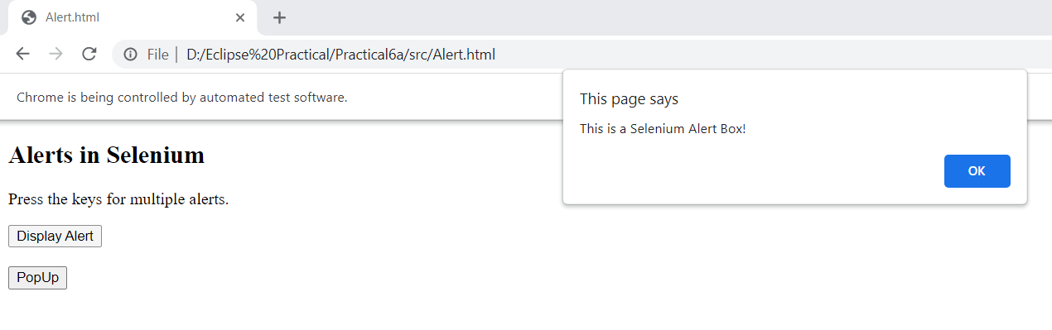

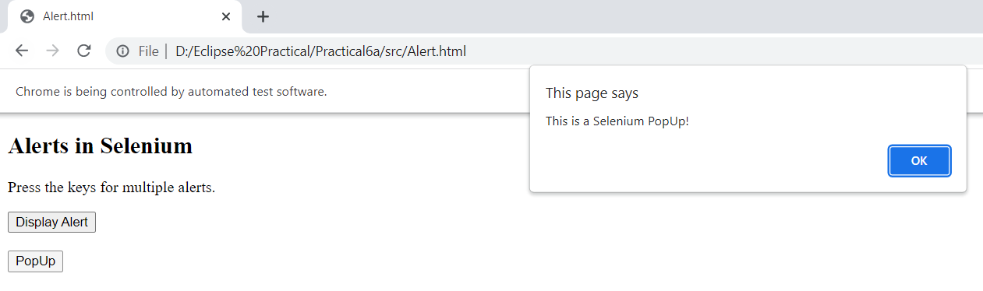

**Practical 7**

**Aim: Demonstrate Handling Drop Down and List Boxes**

**7.1: Demonstrate Handling Drop Down**

**Code:**

**package** dropdown;

**import** org.openqa.selenium.By;

**import** org.openqa.selenium.WebDriver;

**import** org.openqa.selenium.WebElement;

**import** org.openqa.selenium.chrome.ChromeDriver;

**import** org.openqa.selenium.support.ui.Select;

**public** **class** Dropdown {

**public** **static** **void** main(String[] args) **throws** InterruptedException {

// **TODO** Auto-generated method stub

System.*setProperty*("webdriver.chrome.driver", "E:\\FYMCA SEM3\\STQA PRACT\\Selenium-SoftwareTesting\\chromedriver.exe" );

WebDriver driver=**new** ChromeDriver();

driver.get("https://www.facebook.com/signup");

driver.manage().window().maximize();

WebElement day_d=driver.findElement(By.*id*("day"));

Select oSelect =**new** Select(day_d);

Thread.*sleep*(3000);

oSelect.selectByIndex(6);

WebElement month_m=driver.findElement(By.*id*("month"));

Select month_m1=**new** Select(month_m);

Thread.*sleep*(3000);

month_m1.selectByVisibleText("Jul");

WebElement year_y=driver.findElement(By.*id*("year"));

Select year_y1=**new** Select(year_y);

Thread.*sleep*(3000);

year_y1.selectByValue("2000");

}

}

**Output:**

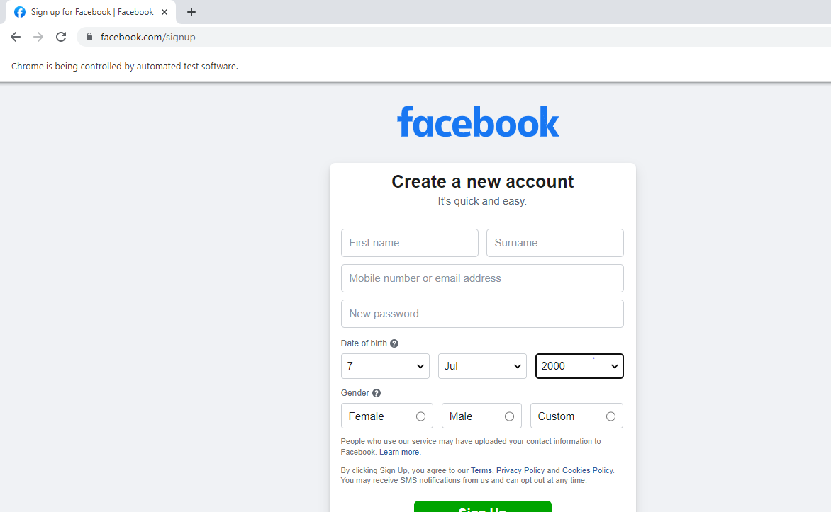

**Code:**

**package** Practical7a;

**import** java.util.List;

**import** java.util.concurrent.TimeUnit;

**import** org.openqa.selenium.By;

**import** org.openqa.selenium.WebDriver;

**import** org.openqa.selenium.WebElement;

**import** org.openqa.selenium.chrome.ChromeDriver;

**import** org.openqa.selenium.support.ui.Select;

**public** **class** Practical7a {

**public** **static** **void** main(String[] args) **throws** InterruptedException {

System.*setProperty*("webdriver.chrome.driver", "D:\\Eclipse Practical\\chromedriver.exe");

WebDriver driver = **new** ChromeDriver();

driver.get("https://www.facebook.com/signup");

driver.manage().window().maximize();

WebElement day_d=driver.findElement(By.*id*("day"));

//Select Declaration

Select oSelect = **new** Select(day_d);

Thread.*sleep*(3000);

List<WebElement> day_d1=oSelect.getOptions();

**int** total_days=day_d1.size();

System.***out***.println("Total count is:"+total_days);

**for**(WebElement ele:day_d1)

{

String day_1=ele.getText();

System.***out***.println("Days are"+day_1);

}

driver.quit();

}

}

**Output:**

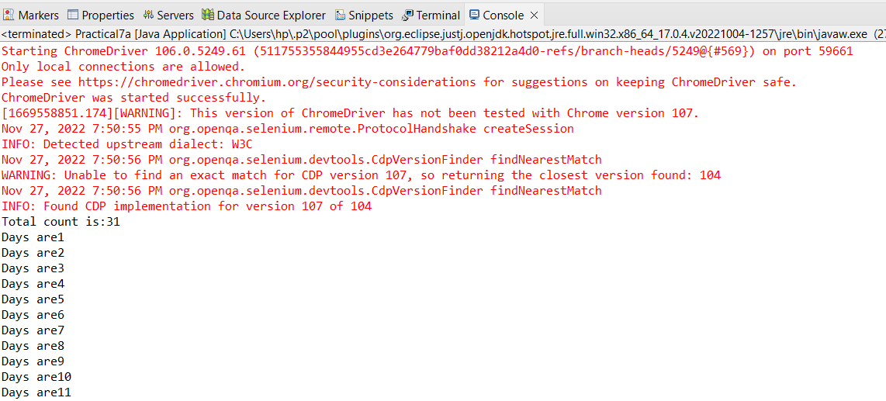

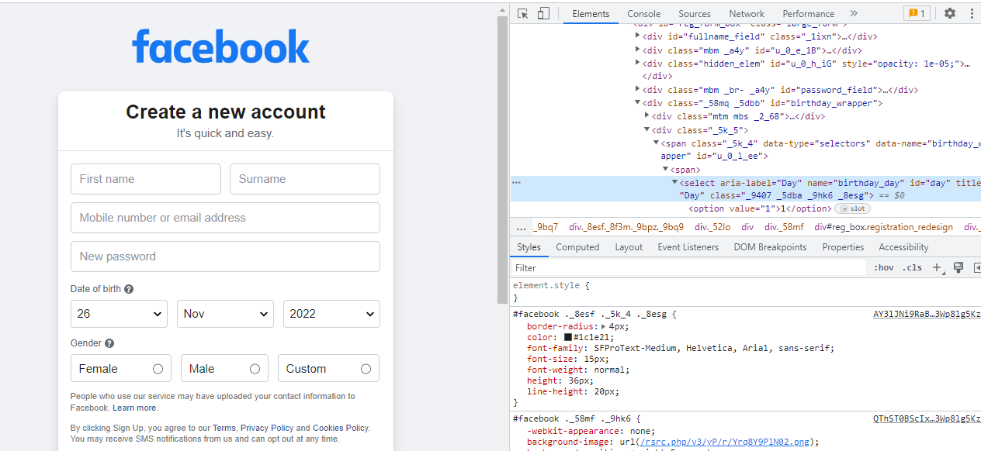

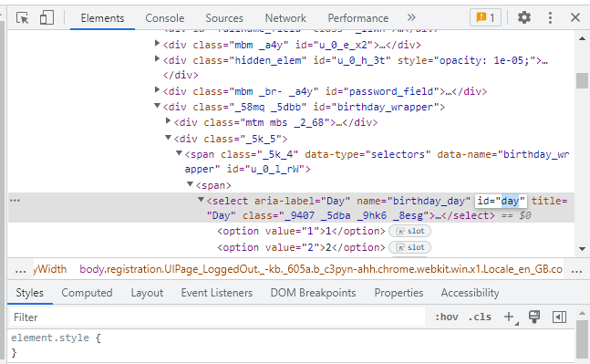

**Code:SelectByValue:**

**package** byValue;

**import** org.openqa.selenium.By;

**import** org.openqa.selenium.WebDriver;

**import** org.openqa.selenium.WebElement;

**import** org.openqa.selenium.chrome.ChromeDriver;

**import** org.openqa.selenium.support.ui.Select;

**public** **class** ByValue {

**public** **static** **void** main(String[] args) {

// **TODO** Auto-generated method stub

System.*setProperty*("webdriver.chrome.driver", "E:\\FYMCA SEM3\\STQA PRACT\\Selenium-SoftwareTesting\\chromedriver.exe" );

WebDriver driver=**new** ChromeDriver();

driver.get("http://www.facebook.com/signup");

driver.manage().window().maximize();

WebElement selectByIndex = driver.findElement(By.*id*("day"));

Select selByIndex=**new** Select(selectByIndex);

selByIndex.selectByIndex(10);

System.***out***.println("Day is Selected");

WebElement seleByVal=driver.findElement(By.*id*("month"));

Select selByVal = **new** Select(seleByVal);

selByVal.selectByValue("5");

System.***out***.println("The Month is selected");

WebElement seleByText=driver.findElement(By.*id*("year"));

Select selByTxt=**new** Select(seleByText);

selByTxt.selectByVisibleText("2016");

System.***out***.println("The year is selected");

}

}

**Output:**

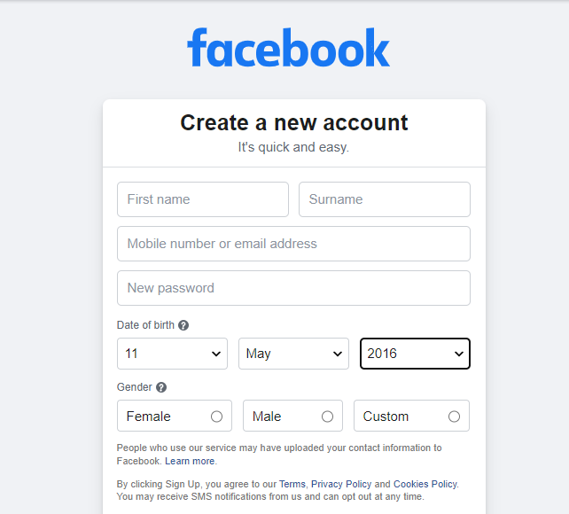

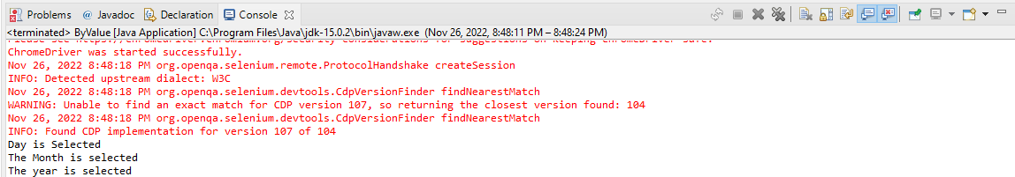

**7.2: Demonstrate Handling List Boxes**

**Code:**

**Practical7b.java:**

**package** Practical7b;

**import** java.util.concurrent.TimeUnit;

**import** org.openqa.selenium.By;

**import** org.openqa.selenium.WebDriver;

**import** org.openqa.selenium.WebElement;

**import** org.openqa.selenium.chrome.ChromeDriver;

**import** org.openqa.selenium.firefox. FirefoxDriver;

**import** org.openqa.selenium.support.ui.Select;

**public** **class** Practical7b {

**public** **static** **void** main(String[] args) {

// **TODO** Auto-generated method stub

System. *setProperty*("webdriver.chrome.driver","D:\\Eclipse Practical\\chromedriver.exe");

WebDriver driver = **new** ChromeDriver();

driver.manage().window().maximize();

driver.manage().timeouts().~~implicitlyWait~~(10, TimeUnit.***SECONDS***);

driver.get("D:\\Eclipse Practical\\Practical6b\\src\\Practical6b\\listbox.html");

WebElement listbox = driver.findElement(By.*id*("city")); Select select =**new** Select (listbox);

select.selectByIndex(1);

select.selectByValue("c");

select.selectByVisibleText("DELHI");

}

}

**Listbox.html:**

<html> <body>

<select id="city">

<option value="a">AGRA</option>

<option value="b">BANGALORE</option>

<option value="c">CHENNAI</option>

<option value="d">DELHI</option>

<option value="m">MYSORE</option>

<option value="p">PATNA</option>

</select>

</body> </html>

**Output:**

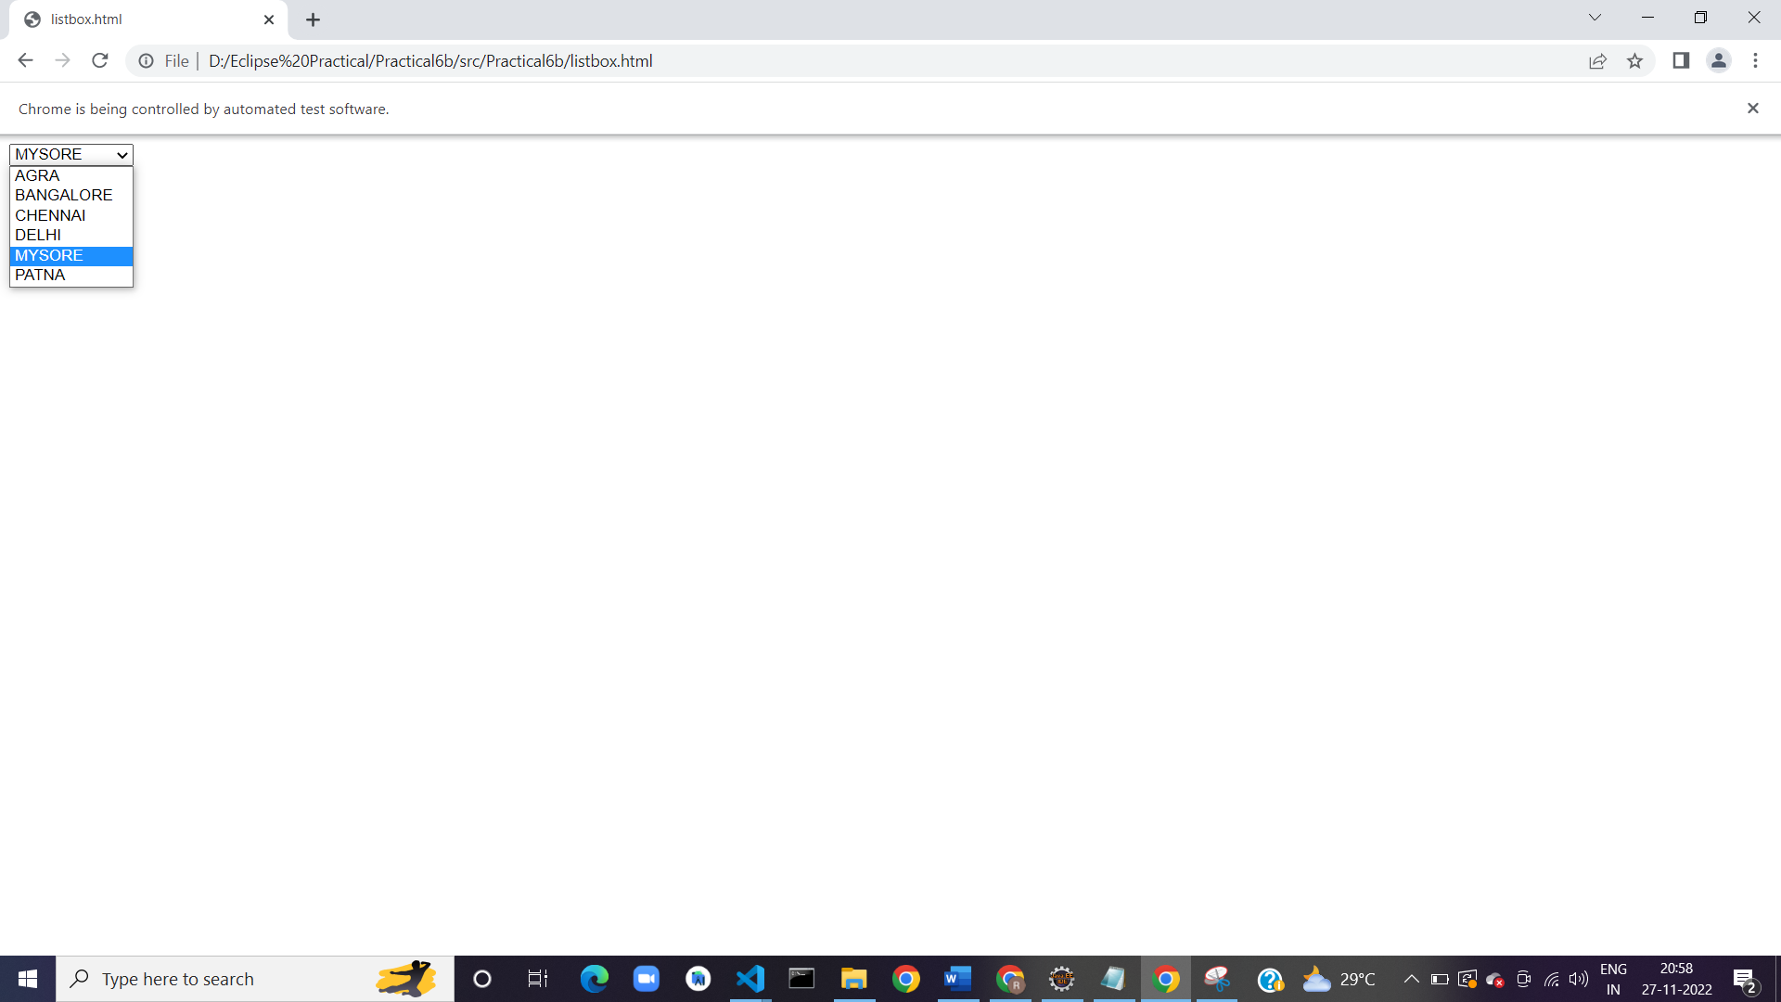

**Practical 8**

**Aim: Demonstrate Radio Button and Check Boxes**

**8.1) Radio Button. (using Click)**

**Code:**

**package** practical8a;

**import** org.openqa.selenium.By;

**import** org.openqa.selenium.WebDriver;

**import** org.openqa.selenium.chrome.ChromeDriver;

**public** **class** practical8a {

**public** **static** **void** main(String[] args) {

// **TODO** Auto-generated method stub

System.*setProperty*("webdriver.chrome.driver","D:\\Eclipse Practical\\chromedriver.exe");

WebDriver driver = **new** ChromeDriver();

//Visit a page

driver.get("D:\\Eclipse Practical\\Practical8\\src\\practical8a\\RadioButton.html");

//Check a radio button

driver. findElement (By. *xpath*("//*[text()='HTML']/preceding-sibling::input")).click();

}

}

**Output:**

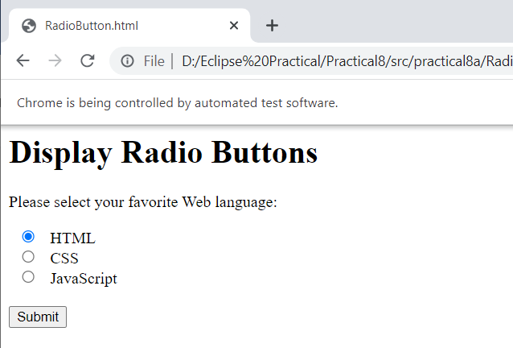

**8.2) Using Value of radio button.**

**Code:**

**package** practical8b;

**import** org.openqa.selenium.By;

**import** org.openqa.selenium.WebDriver;

**import** org.openqa.selenium.chrome.ChromeDriver;

**public** **class** practical8b {

**public** **static** **void** main(String[] args) {

// **TODO** Auto-generated method stub

System.*setProperty*("webdriver.chrome.driver","D:\\Eclipse Practical\\chromedriver.exe");

WebDriver driver = **new** ChromeDriver();

//Visit a page

driver.get("D:\\Eclipse Practical\\Practical8\\src\\practical8a\\RadioButton.html");

//Check a radio button

**if** (driver. findElement (By.*xpath*("//*[text()='HTML']/preceding-sibling::input")).getAttribute("value").matches("HTML"))

{

driver. findElement (By.*xpath*("//*[text()='HTML']/preceding-sibling::input")).click();

}

}

}

**Output:**

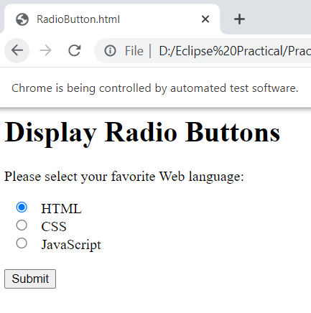

**8.3) To check radio button selected by using .isSelected()**

**Code:**

**package** practical8c;

**import** org.openqa.selenium.By;

**import** org.openqa.selenium.WebDriver;

**import** org.openqa.selenium.chrome.ChromeDriver;

**public** **class** practical8c {

**public** **static** **void** main(String[] args) {

// **TODO** Auto-generated method stub

System.*setProperty*("webdriver.chrome.driver","D:\\Eclipse Practical\\chromedriver.exe");

WebDriver driver = **new** ChromeDriver();

//Visit a page

driver.get("D:\\Eclipse Practical\\Practical8\\src\\practical8a\\RadioButton.html");

//Check a radio button

driver.findElement(By.*xpath*("//*[text()='HTML']/preceding-sibling::input")) .click();

**if** (driver. findElement (By.*xpath*("//*[text()='HTML']/preceding-sibling::input")).isSelected()==**true**)

{

System.***out***.println("First option is selected");

}

}

}

**Output:**

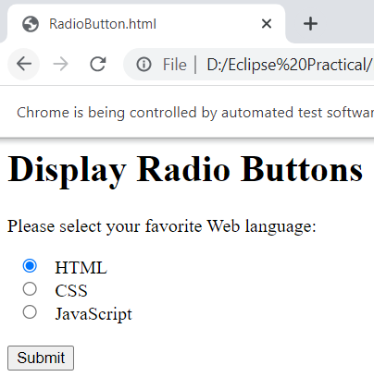

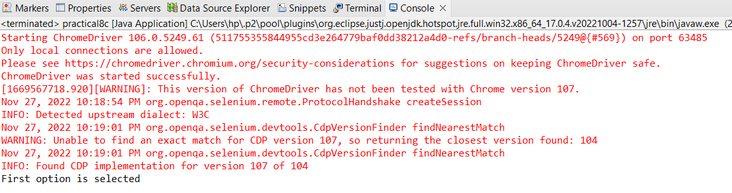

**8.4) To demonstrate Checkboxes. (Single Selection)**

**Code:**

**package** practical8d;

**import** org.openqa.selenium.By;

**import** org.openqa.selenium.WebDriver;

**import** org.openqa.selenium.chrome.ChromeDriver;

**public** **class** practical8d {

**public** **static** **void** main(String[] args) {

// **TODO** Auto-generated method stub

System.*setProperty*("webdriver.chrome.driver","D:\\Eclipse Practical\\chromedriver.exe");

WebDriver driver=**new** ChromeDriver();

driver.get("https://itera-qa.azurewebsites.net/home/automation") ;

//1) select specific check box

driver. findElement (By.*xpath*("//input[@id='monday']")).click();

}

}

**Output:**

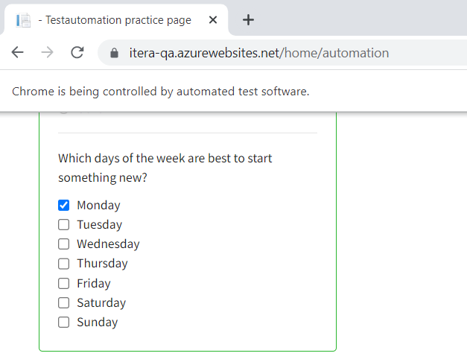

**8.5) Checkboxes: (Select All)**

**Code:**

**package** practical8e;

**import** java.util.List;

**import** org.openqa.selenium.By;

**import** org.openqa.selenium.WebDriver;

**import** org.openqa.selenium.WebElement;

**import** org.openqa.selenium.chrome.ChromeDriver;

**public** **class** practical8e {

**public** **static** **void** main(String[] args) {

// **TODO** Auto-generated method stub

System.*setProperty*("webdriver.chrome.driver","D:\\Eclipse Practical\\chromedriver.exe");

WebDriver driver=**new** ChromeDriver();

driver.get("https://itera-qa.azurewebsites.net/home/automation") ;

//2) Select all the check boxes

List<WebElement>checkboxes=driver .findElements (By.*xpath*("//input[@type='checkbox' and contains(@id, 'day')]"));

System.***out***.println("Total No of check boxes:"+checkboxes.size());

}

}

**Output:**

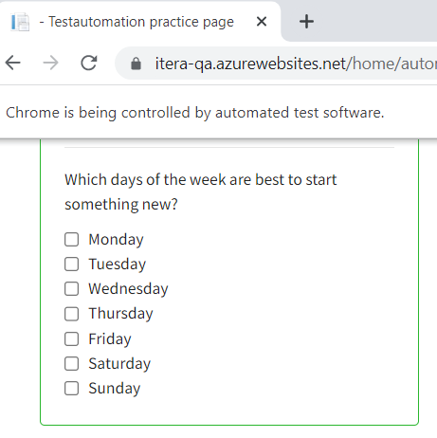

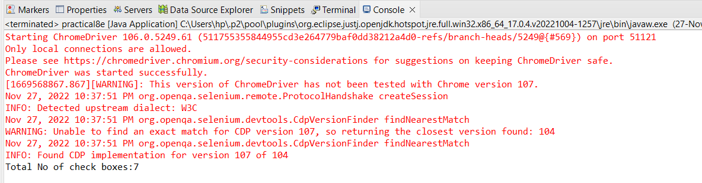

**Code:**

**package** practical8f;

**import** java.util.List;

**import** org.openqa.selenium.By;

**import** org.openqa.selenium.WebDriver;

**import** org.openqa.selenium.WebElement;

**import** org.openqa.selenium.chrome.ChromeDriver;

**public** **class** practical8f {

**public** **static** **void** main(String[] args) {

// **TODO** Auto-generated method stub

System.*setProperty*("webdriver.chrome.driver","D:\\Eclipse Practical\\chromedriver.exe");

WebDriver driver=**new** ChromeDriver();

driver.get("https://itera-qa.azurewebsites.net/home/automation") ;

//2) Select all the check boxes

List<WebElement>checkboxes=driver .findElements (By.*xpath*("//input[@type='checkbox' and contains(@id, 'day')]"));

//System.out.println("Total No of check boxes:"+checkboxes.size());

**for**(WebElement chbox:checkboxes) {

chbox.click();

}

}

}

**Output:**

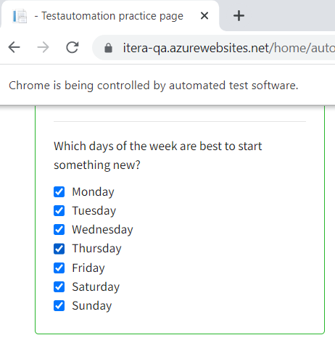

**8.6) Checkboxes: (Multiple Check Boxes)**

**Code:**

**package** practical8g;

**import** java.util.List;

**import** org.openqa.selenium.By;

**import** org.openqa.selenium.WebDriver;

**import** org.openqa.selenium.WebElement;

**import** org.openqa.selenium.chrome.ChromeDriver;

**public** **class** practical8g {

**public** **static** **void** main(String[] args) {

// **TODO** Auto-generated method stub

// **TODO** Auto-generated method stub

System.*setProperty*("webdriver.chrome.driver","D:\\Eclipse Practical\\chromedriver.exe");

WebDriver driver=**new** ChromeDriver();

driver.get("https://itera-qa.azurewebsites.net/home/automation") ;

//2) Select all the check boxes

List<WebElement>checkboxes=driver .findElements (By.*xpath*("//input[@type='checkbox' and contains(@id, 'day')]"));

**for**(WebElement chbox: checkboxes)

{

String checkboxname=chbox.getAttribute("id"); {

**if** (checkboxname.equals("monday") || checkboxname.equals("sunday"))

chbox.click(); }}

}

}

**Output:**

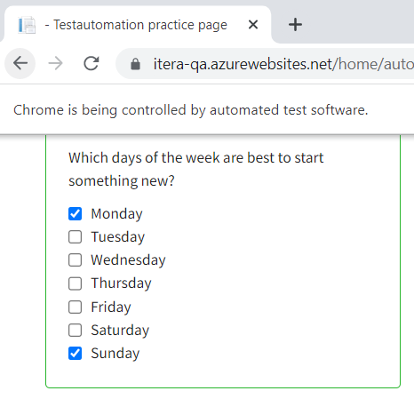

**8.7) Checkboxes: (Last 2 Check boxes selection)**

**Code:**

**package** practical8g;

**import** java.util.List;

**import** org.openqa.selenium.By;

**import** org.openqa.selenium.WebDriver;

**import** org.openqa.selenium.WebElement;

**import** org.openqa.selenium.chrome.ChromeDriver;

**public** **class** practical8g {

**public** **static** **void** main(String[] args) {

// **TODO** Auto-generated method stub

// **TODO** Auto-generated method stub

System.*setProperty*("webdriver.chrome.driver","D:\\Eclipse Practical\\chromedriver.exe");

WebDriver driver=**new** ChromeDriver();

driver.get("https://itera-qa.azurewebsites.net/home/automation") ;

//2) Select all the check boxes

List<WebElement>checkboxes=driver .findElements (By.*xpath*("//input[@type='checkbox' and contains(@id, 'day')]"));

**int** totalcheckboxes=checkboxes.size();

**for**(**int** i=totalcheckboxes-2;i<totalcheckboxes;i++)

{

checkboxes.get(i).click();

}

}

}

**Output:**

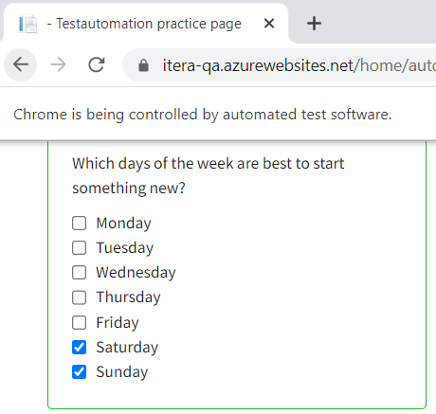

**8.8) Checkboxes: (First 3 Check boxes selection**

**Code:**

**package** practical8g;

**import** java.util.List;

**import** org.openqa.selenium.By;

**import** org.openqa.selenium.WebDriver;

**import** org.openqa.selenium.WebElement;

**import** org.openqa.selenium.chrome.ChromeDriver;

**public** **class** practical8g {

**public** **static** **void** main(String[] args) {

// **TODO** Auto-generated method stub

// **TODO** Auto-generated method stub

System.*setProperty*("webdriver.chrome.driver","D:\\Eclipse Practical\\chromedriver.exe");

WebDriver driver=**new** ChromeDriver();

driver.get("https://itera-qa.azurewebsites.net/home/automation") ;

//2) Select all the check boxes

List<WebElement>checkboxes=driver .findElements (By.*xpath*("//input[@type='checkbox' and contains(@id, 'day')]"));

**int** totalcheckboxes=checkboxes.size();

**for**(**int** i=0;i<totalcheckboxes;i++)

{

**if**(i<3) {

checkboxes.get(i).click();

}

}

}

}

**Output:**

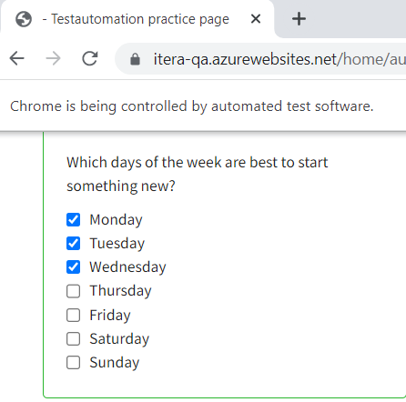

**Practical 9**

**Aim: Demonstrate Action Classes in Selenium.**

**Code:**

**1)Action class:**

**package** actionClass;

**import** org.openqa.selenium.By;

**import** org.openqa.selenium.Keys;

**import** org.openqa.selenium.WebDriver;

**import** org.openqa.selenium.WebElement;

**import** org.openqa.selenium.chrome.ChromeDriver;

**import** org.openqa.selenium.interactions.Actions;

**public** **class** Action {

**public** **static** **void** main(String[] args) **throws** InterruptedException {

// **TODO** Auto-generated method stub

System.*setProperty*("webdriver.chrome.driver", "E:\\FYMCA SEM3\\STQA PRACT\\Selenium-SoftwareTesting\\chromedriver.exe" );

WebDriver driver=**new** ChromeDriver();

driver.manage().window().maximize();

driver.get("https://www.google.com/search?q=business+vector+icons&source=lnms&tbm=isch&sa=X&ved=2ahUKEwjHhcyTzsz7AhWVyzgGHXc8AzYQ_AUoAXoECAMQAw&biw=1242&bih=568&dpr=1.1#imgrc=rGN4eIuJn6LBMM");

Thread.*sleep*(1000);

WebElement googleSearch=driver.findElement(By.*name*("q"));

Actions act=**new** Actions(driver);

act.keyDown(googleSearch,Keys.***SHIFT***).sendKeys("selenium");

}

}

**Output:**

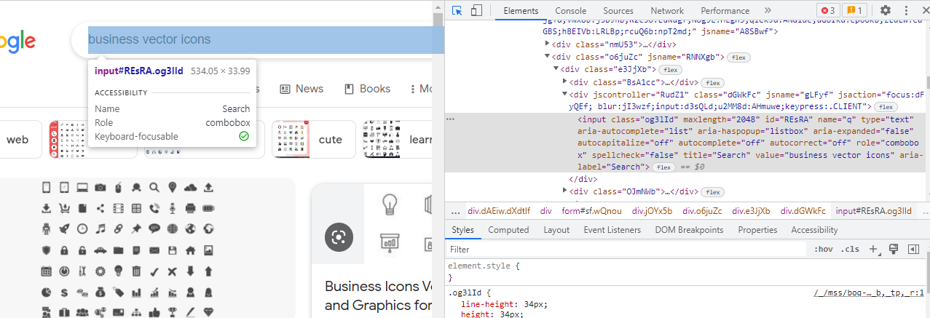

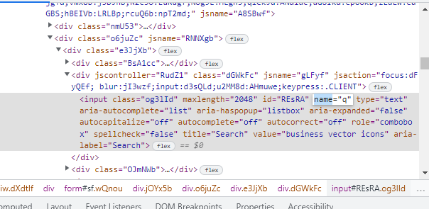

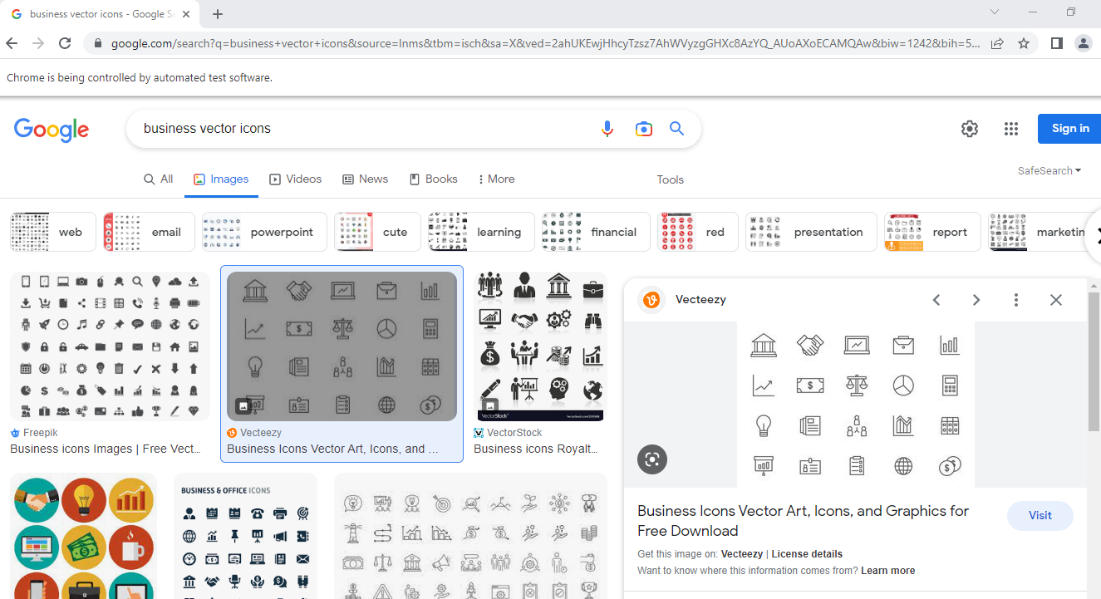

**2)Action Class build and perform**

**package** Practical9;

**import** org.openqa.selenium.By;

**import** org.openqa.selenium.Keys;

**import** org.openqa.selenium.WebDriver;

**import** org.openqa.selenium.WebElement;

**import** org.openqa.selenium.chrome.ChromeDriver;

**import** org.openqa.selenium.interactions.Actions;

**public** **class** Practical9 {

**public** **static** **void** main(String[] args) **throws** InterruptedException {

// **TODO** Auto-generated method stub

WebDriver driver;

System. *setProperty*("webdriver.chrome.driver" ,"D:\\Eclipse Practical\\chromedriver.exe");

driver = **new** ChromeDriver();

driver.manage().window().maximize();

driver.get("https://www.google.com/");

Thread. *sleep*(1000) ;

WebElement googleSearch=driver.findElement (By.*name*("q"));

Actions act=**new** Actions(driver);

act.keyDown(googleSearch, Keys.***SHIFT***)

.sendKeys("selenium")

.build()

.perform();

}

}

**Output:**

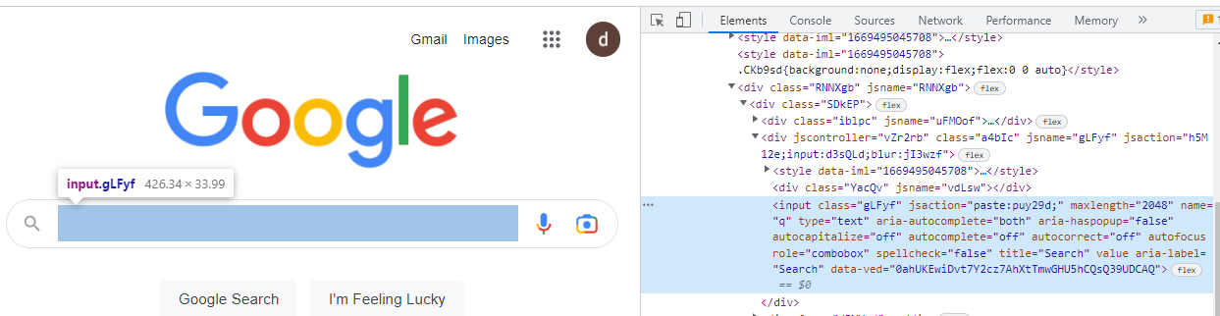

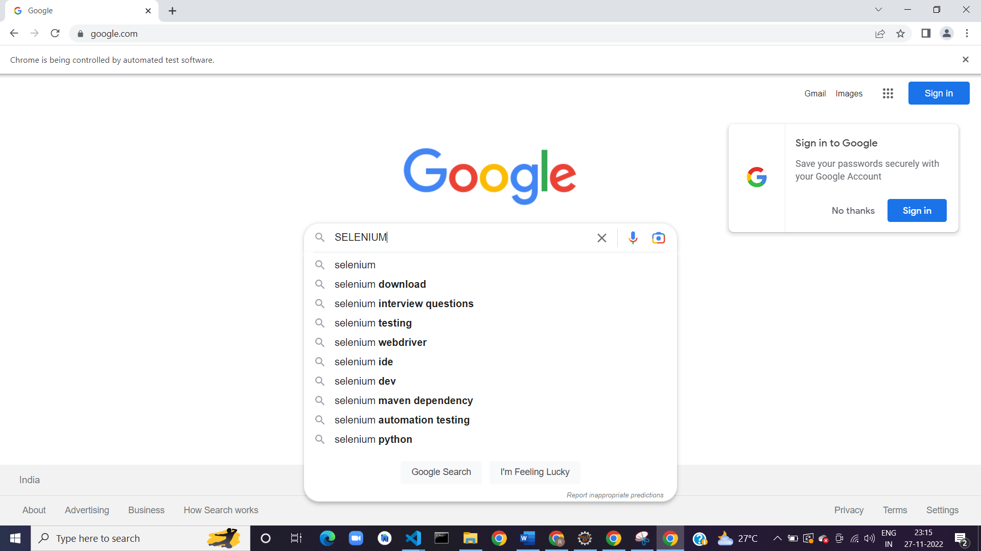

**3) Action KeyUp & down**

**package** keyUp;

**import** org.openqa.selenium.By;

**import** org.openqa.selenium.Keys;

**import** org.openqa.selenium.WebDriver;

**import** org.openqa.selenium.WebElement;

**import** org.openqa.selenium.chrome.ChromeDriver;

**import** org.openqa.selenium.interactions.Actions;

**public** **class** KeyUp {

**public** **static** **void** main(String[] args) {

// **TODO** Auto-generated method stub

System.*setProperty*("webdriver.chrome.driver", "E:\\FYMCA SEM3\\STQA PRACT\\Selenium-SoftwareTesting\\chromedriver.exe" );

WebDriver driver=**new** ChromeDriver();

driver.manage().window().maximize();

driver.get("https://www.google.com");

WebElement googleSearch=driver.findElement(By.*name*("q"));

Actions act=**new** Actions(driver);

act.keyDown(googleSearch,Keys.***SHIFT***)

.sendKeys("selenium")

.keyUp(googleSearch,Keys.***SHIFT***)

.keyDown(googleSearch,Keys.***CONTROL***)

.sendKeys("a")

.build()

.perform();

}

}

**Output:**

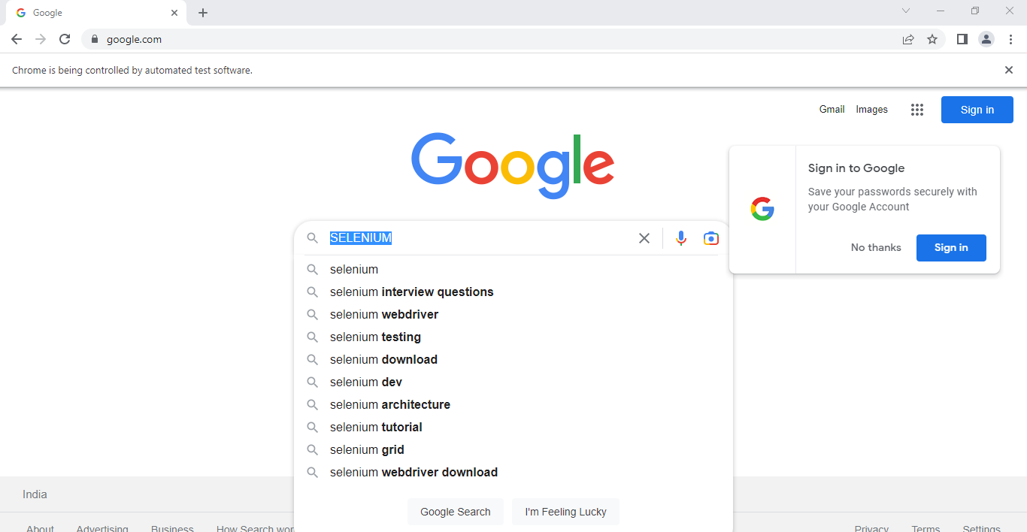

**package** action;

**import** org.openqa.selenium.By;

**import** org.openqa.selenium.Keys;

**import** org.openqa.selenium.WebDriver;

**import** org.openqa.selenium.WebElement;

**import** org.openqa.selenium.chrome.ChromeDriver;

**import** org.openqa.selenium.interactions.Actions;

**public** **class** ActionC4 {

**public** **static** **void** main(String[] args) **throws** InterruptedException {

// **TODO** Auto-generated method stub

System.*setProperty*("webdriver.chrome.driver", "E:\\FYMCA SEM3\\STQA PRACT\\Selenium-SoftwareTesting\\chromedriver.exe" );

WebDriver driver=**new** ChromeDriver();

driver.manage().window().maximize();

driver.get("https://www.google.com");

WebElement googleSearch=driver.findElement(By.*name*("q"));

Actions act=**new** Actions(driver);

act.keyDown(googleSearch,Keys.***SHIFT***)

.sendKeys("selenium")

.keyUp(googleSearch,Keys.***SHIFT***)

.keyDown(googleSearch,Keys.***CONTROL***)

.sendKeys("a")

.keyDown(googleSearch,Keys.***CONTROL***)

.sendKeys("x")

.build()

.perform();

Thread.*sleep*(5000);

driver.close();

}

}

**Output:**



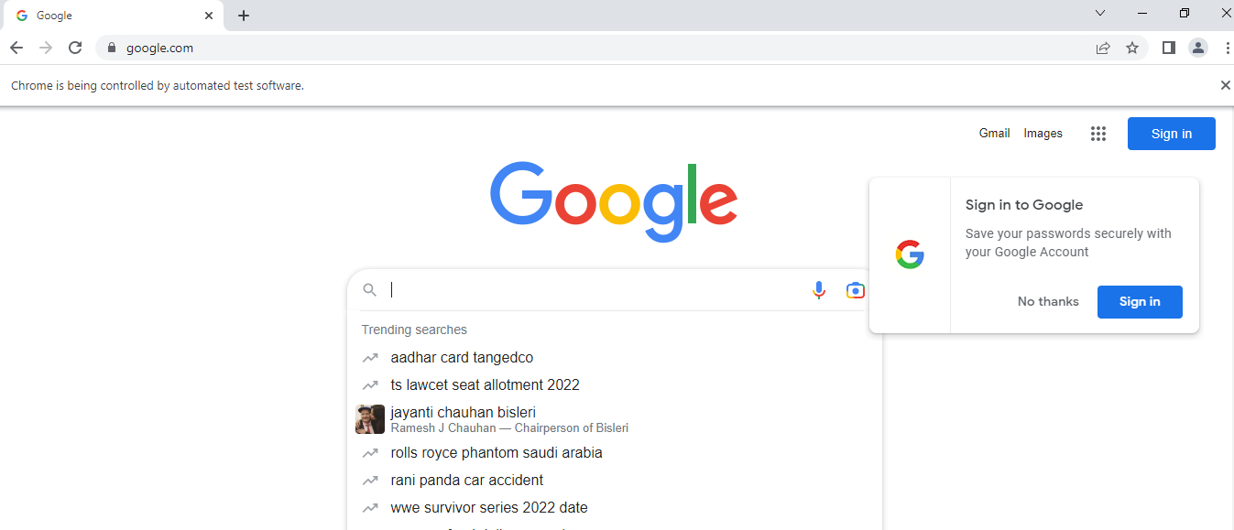

**package** action;

**import** org.openqa.selenium.By;

**import** org.openqa.selenium.Keys;

**import** org.openqa.selenium.WebDriver;

**import** org.openqa.selenium.WebElement;

**import** org.openqa.selenium.chrome.ChromeDriver;

**import** org.openqa.selenium.interactions.Actions;

**public** **class** ActionC5 {

**public** **static** **void** main(String[] args) **throws** InterruptedException {

// **TODO** Auto-generated method stub

System.*setProperty*("webdriver.chrome.driver", "E:\\FYMCA SEM3\\STQA PRACT\\Selenium-SoftwareTesting\\chromedriver.exe" );

WebDriver driver=**new** ChromeDriver();

driver.manage().window().maximize();

driver.get("https://www.google.com");

WebElement googleSearch=driver.findElement(By.*name*("q"));

Actions act=**new** Actions(driver);

act.keyDown(googleSearch,Keys.***SHIFT***)

.sendKeys("selenium")

.keyUp(googleSearch,Keys.***SHIFT***)

.keyDown(googleSearch,Keys.***CONTROL***)

.sendKeys("a")

.keyDown(googleSearch,Keys.***CONTROL***)

.sendKeys("x")

.keyDown(googleSearch,Keys.***CONTROL***)

.sendKeys("v")

.build()

.perform();

Thread.*sleep*(5000);

driver.close();

}

}

**Output:**





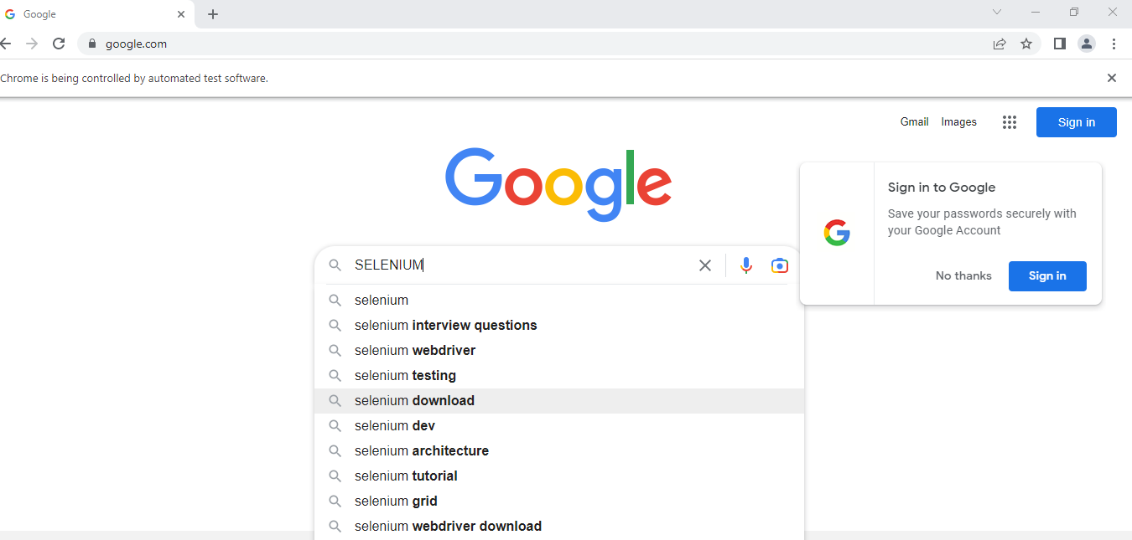

**4)ActionClass & Interface:**

**package** action;

**import** org.openqa.selenium.By;

**import** org.openqa.selenium.Keys;

**import** org.openqa.selenium.WebDriver;

**import** org.openqa.selenium.WebElement;

**import** org.openqa.selenium.chrome.ChromeDriver;

**import** org.openqa.selenium.interactions.Action;

**import** org.openqa.selenium.interactions.Actions;

**public** **class** ActionC6 {

**public** **static** **void** main(String[] args) **throws** InterruptedException {

// **TODO** Auto-generated method stub

System.*setProperty*("webdriver.chrome.driver", "E:\\FYMCA SEM3\\STQA PRACT\\Selenium-SoftwareTesting\\chromedriver.exe" );

WebDriver driver=**new** ChromeDriver();

driver.manage().window().maximize();

driver.get("https://www.google.com");

WebElement googleSearch=driver.findElement(By.*name*("q"));

Actions act=**new** Actions(driver);

Action action=act.keyDown(googleSearch,Keys.***SHIFT***)

.sendKeys("selenium")

.keyUp(googleSearch,Keys.***SHIFT***)

.keyDown(googleSearch,Keys.***CONTROL***)

.sendKeys("a")

.keyDown(googleSearch,Keys.***CONTROL***)

.sendKeys("x")

.keyDown(googleSearch,Keys.***CONTROL***)

.sendKeys("v")

.build();

action.perform();//Action class & Action Interface

Thread.*sleep*(5000);

driver.close();

}

}

**Output:**







**Practical 10**

**Aim: Installation of TestNg, running testNg and TestNg annotations.**

**10.1) Installation of TestNg.**

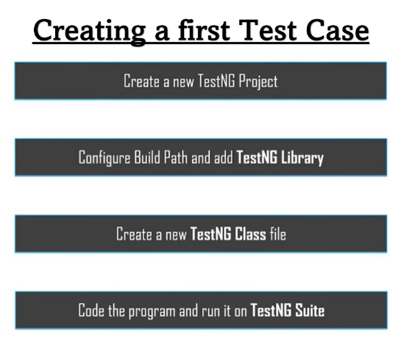

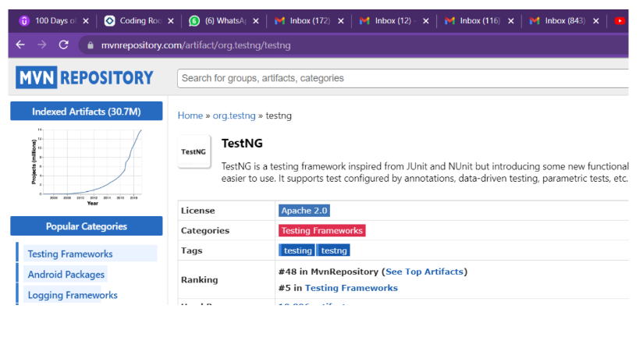

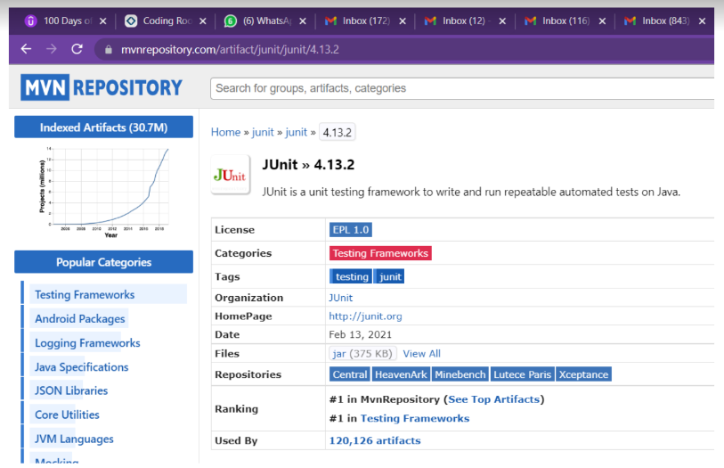

**10.2) Program to run TestNg.**

**Code:**

package testNG;

import org.openqa.selenium.WebDriver;

import org.openqa.selenium.chrome.ChromeDriver;

import org.testng.Assert;

import org.testng.annotations.*;

public class TestNG {

public String baseUrl = "https://www.edureka.co/";

String driverPath = "E:\\FYMCA SEM3\\STQA PRACT\\Selenium-SoftwareTesting\\chromedriver.exe";

public WebDriver driver ;

@Test

public void verifyHomepageTitle() {

System.out.println("Launching Chrome Browser");

System. setProperty("webdriver.chrome.driver", driverPath) ;

driver = new ChromeDriver();

driver.get(baseUrl);

String expectedTitle = "Instructor-Led Online Training with 24X7 Lifetime Support | Edureka";

String actualTitle = driver.getTitle();

Assert.assertEquals(actualTitle, expectedTitle);

driver.close();

}

}

**Output:**

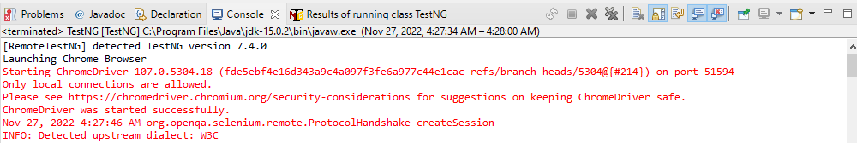

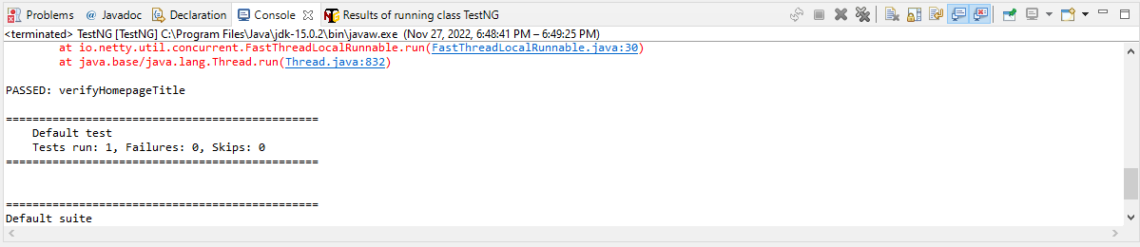

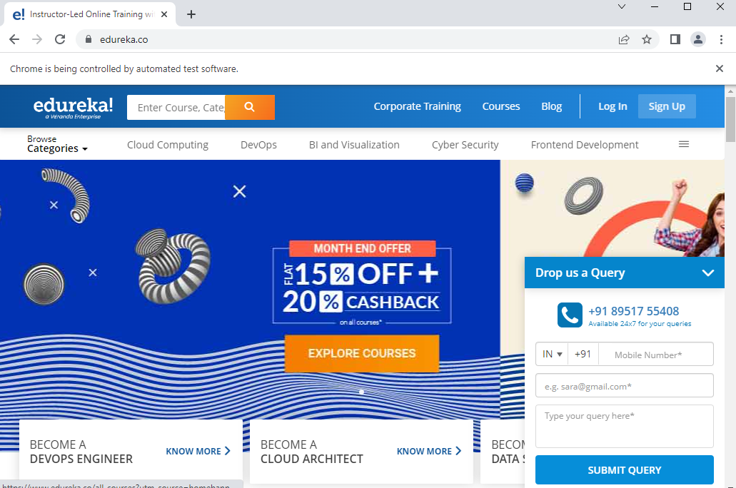

**package** testNG2;

**import** org.openqa.selenium.WebDriver;

**import** org.openqa.selenium.chrome.ChromeDriver;

**import** org.testng.Assert;

**import** org.testng.annotations.Test;

**public** **class** TestNG2 {

**public** String baseUrl = "https://www.edureka.co/";

String driverPath ="E:\\FYMCA SEM3\\STQA PRACT\\Selenium-SoftwareTesting\\chromedriver.exe";

**public** WebDriver driver ;

@Test

**public** **void** verifyHomepageTitle() {

System.***out***.println("Launching Chrome Browser");

System. *setProperty*("webdriver.chrome.driver",driverPath) ;

driver = **new** ChromeDriver();

driver.get(baseUrl);

String expectedTitle = "Instructor-Led Online Training with 24X7 Lifetime Support Edureka"; // If stripe removed, then shows error.

String actualTitle = driver.getTitle();

Assert.*assertEquals*(actualTitle, expectedTitle);

driver.close();

}

}

**Output:**

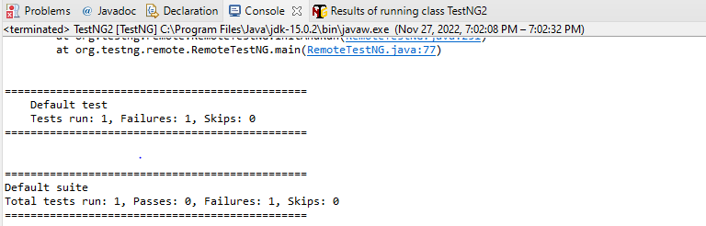

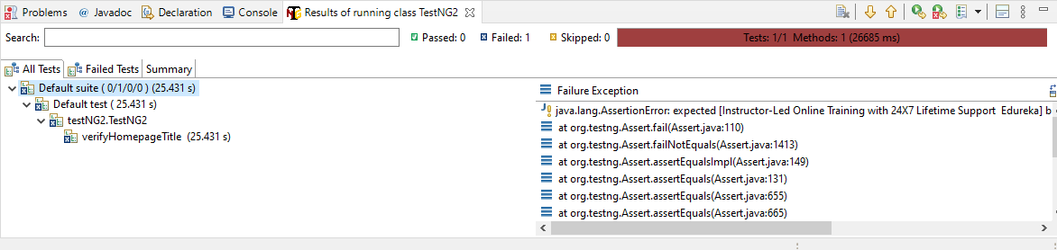



**10.3) Using TestNg Annotations. (@Beforetest, @Test, @Aftertest).**

**package** testNG3;

**import** org.openqa.selenium.WebDriver;

**import** org.openqa.selenium.chrome.ChromeDriver;

**import** org.testng.Assert;

**import** org.testng.annotations.AfterTest;

**import** org.testng.annotations.BeforeTest;

**import** org.testng.annotations.Test;

**public** **class** AnnotationExample {

**public** String baseUrl = "https://www.edureka.co/";

String driverPath ="E:\\FYMCA SEM3\\STQA PRACT\\Selenium-SoftwareTesting\\chromedriver.exe";

**public** WebDriver driver ;

@BeforeTest

**public** **void** launchBrowser()

{

System.***out***.println("launching Chrome browser");

System.*setProperty*("webdriver.chrome.driver", driverPath);

driver = **new** ChromeDriver();

driver.get(baseUrl);

}

@Test

**public** **void** verifyHomepageTitle()

{

String expectedTitle = "Instructor-Led Online Training with 24X7 Lifetime Support | Edureka";

String actualTitle = driver.getTitle();

Assert.*assertEquals*(actualTitle, expectedTitle);

}

@AfterTest

**public** **void** terminateBrowser()

{

driver.close();

}

}

**Output:**

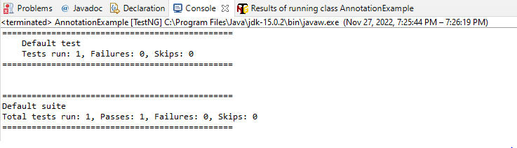

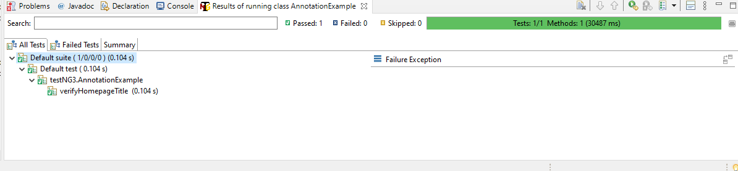



**Practical 11**

**Aim: Demonstrate Data drive framework.**

**Code:**

**DDTEXCEL.java**

**package** datadriven;

**import** org.junit.Test;

**import** org.openqa.selenium.By;

**import** org.openqa.selenium.chrome.ChromeDriver;

**import** org.testng.annotations.AfterMethod;

**import** org.testng.annotations.DataProvider;

**import** graphql.Assert;

**public** **class** DDTExcelTest {

ChromeDriver wd;

@Test(dataProvider = "testdata")

**public** **void** DemoClass(String username, String password) **throws** InterruptedException {

System.*setProperty*("webdriver.chrome.driver", "F:\\chromedriver.exe");

wd = **new** ChromeDriver();

wd.get("https://app.hubspot.com/login");

wd.findElement(By.*name*("username")).sendKeys(username);

wd.findElement(By.*name*("password")).sendKeys(password);

wd.findElement(By.*name*("login")).click();

Thread.*sleep*(5000);

Assert.*assertTrue*(wd.getTitle().matches("HubSpot Login | app.hubspot.com"));

System.***out***.println("Login successful");

}

@AfterMethod

**void** ProgramTermination() {

wd.quit();

}

@DataProvider(name = "testdata")

**public** Object[][] testDataExample() {

ReadExcel config = **new** ReadExcel("C:\\Users\\HP\\Downloads\\DataDrivenFramework.xlsx");

**int** rows = config.getRow;

Object[][] credentials = **new** Object[rows][2];

**for** (**int** i = 0; i < rows; i++) {

credentials[i][0] = config.getData(0, i, 0);

credentials[i][1] = config.getData(0, i, 0);

}

**return** credentials;

}

}

**ReadExcel.java**

**package** datadriven;

**import** java.io.File;

**import** java.io.FileInputStream;

**import** org.apache.poi.xssf.usermodel.XSSFSheet;

**import** org.apache.poi.xssf.usermodel.XSSFWorkbook;

**import** org.junit.runner.RunWith;

**import** org.junit.runners.Suite;

**import** org.junit.runners.Suite.SuiteClasses;

@RunWith(Suite.**class**)

@SuiteClasses({ DDTExcelTest.**class** })

**public** **class** ReadExcel {

XSSFWorkbook wb;

XSSFSheet sheet;

**public** **int** getRow;

**public** ReadExcel(String excelPath) {

**try** {

File s = **new** File(excelPath);

FileInputStream stream = **new** FileInputStream(s);

wb = **new** XSSFWorkbook(stream);

}

**catch**(Exception e) {

System.***out***.println(e.getMessage());

}

}

**public** String getData(**int** sheetnumber, **int** row, **int** column){

sheet = wb.getSheetAt(sheetnumber);

String data = sheet.getRow(row).getCell(column).getStringCellValue();

**return** data;

}

**public** **int** getRowCount(**int** sheetIndex){

**int** row = wb.getSheetAt(sheetIndex).getLastRowNum();

row = row + 1;

**return** row;

}

}

**Output:**

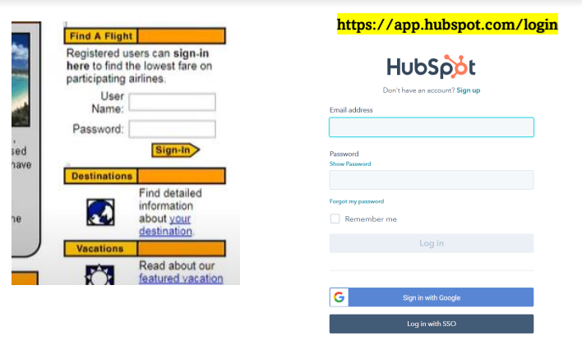

**Practical 12**

**Aim: Introduction of Regression testing with types of it.**

**What Is Regression Testing?**

[What is regression testing](https://u-tor.com/topic/regression-testing-meaning)? The origin of the word “regress” means “going back to the previous state of something”. So regression testing is “perspective testing”, so to say – it’s carried out to verify whether any component of the system is affected by the latest update.

The foundation of regression testing is a proper test case (a set of testing conditions) that defines the scope and the testing approach. We covered that in more detail in our article dedicated to [regression test selection criteria](https://u-tor.com/topic/regression-test-case-selection-criteria). But as a general rule, you want a test case that yields bugs as often as possible. Although it might take a significant amount of time to figure out the right testing type if you do so manually

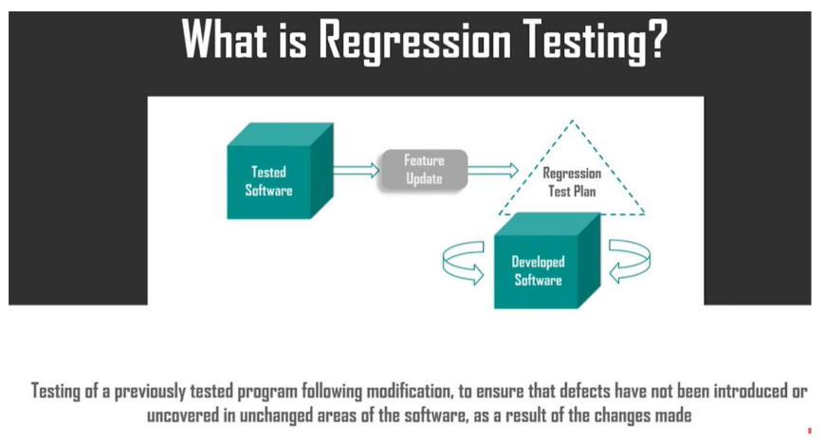

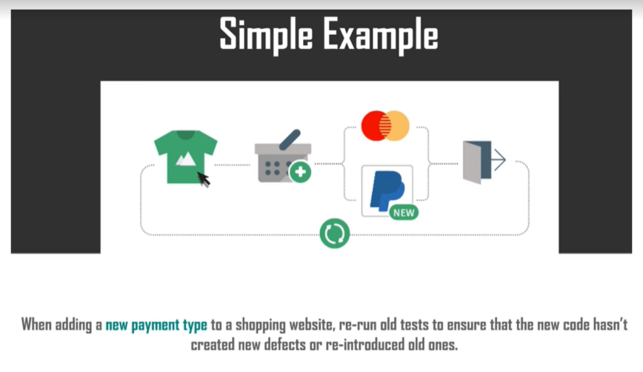

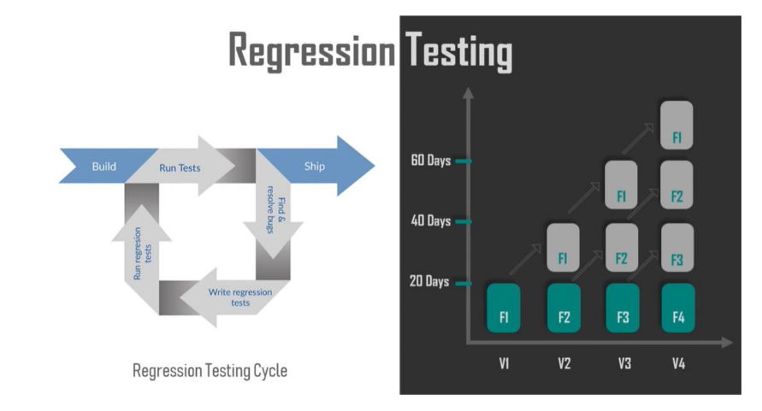

**Types of Regression Testing**

Regression testing comes in different types and forms. How do you pick the one that works for you? Think of your software development life cycle (software development and testing are interconnected) and specific updates that you’re planning to introduce. Here is a display of the common types of regression testing techniques.

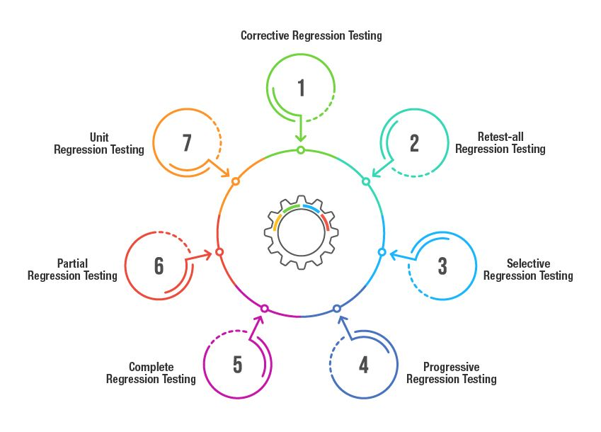

1. **Corrective Regression Testing**

Corrective performance testing is appreciated for its simplicity as it requires fewer efforts. It reuses the existing test cases, given that no major changes in the product specifications have been made (no need to change a testing scenario).

1. **Retest-all Regression Testing**

As the name suggests, this is a complex testing approach that needs all the system’s components tested again from scratch. This test checks retrospectively every small change that’s been made since the very start. Sometimes, this approach is used when suspicions arise that something was missed (or wasn’t done right) during the previous testing stages. Under such circumstances, it can be more effective to retest everything from scratch than attempting to identify what went wrong previously.

It’s not a very common approach, giving the budget concerns; but it gives you more quality reassurance about the system’s current state.

1. **Selective Regression Testing**

This type of testing can be viewed as a middle ground between corrective regression testing and retest-all regression testing: it’s not as basic as the first one, but not as comprehensive as the latter one. Selective regression testing picks certain test cases from a set to inspect the affected parts of the code.

1. **Progressive Regression Testing**

When the established test cases are no longer useful, the newer ones get created. This is often a case when the product specifications are modified, so new test cases must be created to address the changing requirements. Progressive regression testing involves using new testing scenarios when the product vision is affected.

1. **Complete Regression Testing**

Many companies adopt the Agile methodology that encourages doing fewer but frequent updates. In real life, that’s not always possible: companies need to react quickly to the ever-changing client demands. Thus, large-scale system updates are possible (but not likely). But when they do happen, complete regression testing is performed: it’s a must when the root code has been changed.

1. **Partial Regression Testing**

You can view software development as building a LEGO house: you create separate blocks first, then you combine them, and you end up with an entire house.

Your separate modules might have been in development for a while. When you’re about to merge them with a shared code mainline, partial testing is performed, using primarily the existing test cases.

1. **Unit Regression Testing**

That is a straightforward approach that is focused on testing code as a single unit with all the dependencies, integrations, and interactions left outside the scope.

